Beechwood Primary School
Hello!
Kentmere Avenue
Leeds
LS14
Monday 13th July 2020

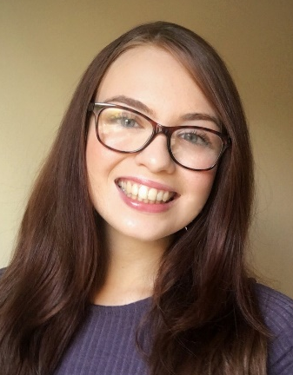
Dear Class 9,
My name is Miss Moss and I will be your year 5 teacher, beginning in September 2020. I am really looking forward to getting to know you all and am sure we will be a great team!
I am new to Beechwood and am delighted to be teaching in such a wonderful school. You will learn lots more about me in September however here are 5 facts about me in the meantime:
- I have recently moved to Leeds from Gloucestershire, in the South-West of England.
- My favourite colour is orange.
- I am a vegan, which means I don’t eat or use any animal products.
- I love to read and my classroom will be full of books!
- My favourite animals are dogs.
In September, we will be Class 11 and our teaching assistant will be Mrs Clarke. Our classroom will be downstairs, which means we will be meeting in the other entrance (you will have used it in Year 3).
When you come back to school in September, we will be learning about the Victorians. We will be finding out about what society was like in this time period and how life was very different than it is today. I will be very impressed if you can find out some information and interesting facts about the Victorians before we begin our topic!
I hope you have a lovely time over the summer holidays. Make sure you spend lots of time playing outside, spending time with your family and relaxing. It would be fantastic if you could also spend time reading a few times a week and practicing your times tables too.
Stay safe and enjoy the summer!
Best Wishes,
Miss Moss

