YEAR 4 HOME LEARNING
Week commencing 22nd June
Thank you to everyone who has sent us photos of their work or emailed us letters to: learning@beechwoodprimaryschool.co.uk We are really impressed with how hard you are all working at home and we love seeing what you are doing.
Don’t forget to look at what everyone else is doing: www.beechwoodprimaryschool.co.uk/what-weve-been-doing-at-home

EXCITING NEWS!
Even though we are not all at school, some of Year 6 have been busy thinking about how we can still do Spirit Alive this year. Next week’s work pack will include information about how you can get involved with the fun while you are at home.

WEBSITES
https://www.bbc.co.uk/bitesize/tags/z63tt39/year-4-and-p5-lessons/1
BBC Bitesize have an excellent range of daily lessons on lots of different subjects for your child to enjoy. New lessons are uploaded every day and include videos, practice activities, games and quizzes to help your child learn. You can watch programmes daily on BBC iPlayer (Bitesize Content)
www.leedsforlearning.co.uk/Page/17071
Leeds for Learning have an excellent range of resources to help support home learning.
MATHS
Please click on the link below and follow these lessons. If possible, send a photo of your home learning via the learning email. We would love to see all the hard work you are doing.
https://whiterosemaths.com/homelearning/year-4/
The WhiteRose maths sheets are now on the school website (Go to the menu and click on Parents, Home Learning Support, Mathematics and Whiterose Maths Sheets.) The WhiteRose hub has teamed up with BBC Bitesize so that their content matches up. This means that you can find videos and additional worksheets on the Bitesize page to help with the learning on the WhiteRose sheets.
For additional arithmetic and times tables practise please use these websites too
Numbots – Years 2-6 - https://play.numbots.com/#/account/school-login/3913 - Use your TT Rock Stars username and password.
Maths Factor – All ages - https://www.themathsfactor.com/
Times Tables Rock Stars (Years 2-6) - https://play.ttrockstars.com/login/3913

SPELLINGS
The spellings to learn for this week include: ly suffix
- bravely calmly carefully
- friendly quietly quickly
- cheekily sneakily happily
- beautifully

Please get someone to test you at the end of the week. Keep a record of your scores!

READING
Please ensure you are reading every day or at least 3 times a week.
Here are some links to some reading websites:
https://www.worldofdavidwalliams.com/elevenses/
Audible Books - https://stories.audible.com/start-listen
World Book –https://worldbook.kitaboo.com/reader/worldbook/

ENGLISH
What did you find out about tourism in the Lake District? What attractions did you find for people to do?
Do you think that the attractions are aimed at different tourists visiting the Lake District. Not everyone would enjoy walking in the fells or taking a boat across the lakes. This week you could think more carefully about the attractions that are offer in the Lake District and who they are for. Can you find some exciting and interesting tourist attractions for people of different ages? Try to find at least 2 different attractions for:
- young children
- older children
- teenagers
- adults
- older adults

Art
As part of our TSU on contrasting localities, our artwork this term is focused on landscapes. One method of sketching is called hatching or crosshatching. It involves using parallel lines to shade in pencil drawings. Here are some examples.

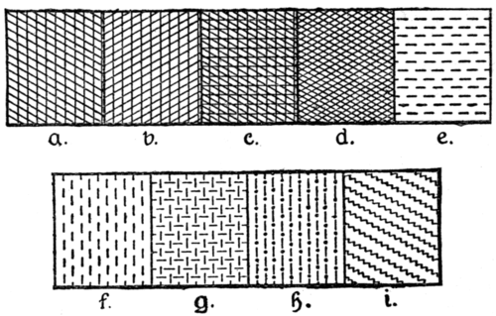
This Photo by Unknown Author is licensed under CC BY-SA

If you have tried practising this method then can you come up with your own style of hatching. Think of different patterns or shapes that you can use to create shadows on pictures. Remember you can test out the following to get different effects:
- Try using pencils/pens that have a different thickness
- Try pressing lightly or harder on the paper
- Try doing lots of lines close together or lines further apart

PHYSICAL ACTIVITIES
Remember to look after both your physical and mental health. They are so important. You might enjoy our fitness fun challenge that you will find on the class pages as well. Have fun keeping fit and healthy.

Please look after yourselves and your family. Stay safe and we hope to see you all again very soon.
Miss Fojt and Miss Hugman

