YEAR 4 HOME LEARNING
Week commencing 15th June
Thank you to everyone who has sent us photos of their work or emailed us letters to: learning@beechwoodprimaryschool.co.uk We are really impressed with how hard you are all working at home and we love seeing what you are doing.
Don’t forget to look at what everyone else is doing: www.beechwoodprimaryschool.co.uk/what-weve-been-doing-at-home

WEBSITES
https://www.bbc.co.uk/bitesize/tags/z63tt39/year-4-and-p5-lessons/1
BBC Bitesize have an excellent range of daily lessons on lots of different subjects for your child to enjoy. New lessons are uploaded every day and include videos, practice activities, games and quizzes to help your child learn. You can watch programmes daily on BBC iPlayer (Bitesize Content)
www.leedsforlearning.co.uk/Page/17071
Leeds for Learning have an excellent range of resources to help support home learning.

MATHS
Please click on the link below and follow these lessons. If possible, send a photo of your home learning via the learning email. We would love to see all the hard work you are doing.
https://whiterosemaths.com/homelearning/year-4/
The WhiteRose maths sheets are now on the school website (Go to the menu and click on Parents, Home Learning Support, Mathematics and Whiterose Maths Sheets.) The WhiteRose hub has teamed up with BBC Bitesize so that their content matches up. This means that you can find videos and additional worksheets on the Bitesize page to help with the learning on the WhiteRose sheets.
For additional arithmetic and times tables practise please use these websites too
Numbots – Years 2-6 - https://play.numbots.com/#/account/school-login/3913 - Use your TT Rock Stars username and password.
Maths Factor – All ages - https://www.themathsfactor.com/
Times Tables Rock Stars (Years 2-6) - https://play.ttrockstars.com/login/3913

SPELLINGS
The spellings to learn for this week include: er suffix
- brighter higher taller
- prouder watcher teacher
- smaller painter happier
- smarter
Please get someone to test you at the end of the week. Keep a record of your scores!

READING
Please ensure you are reading every day or at least 3 times a week.
Here are some links to some reading websites:
https://www.worldofdavidwalliams.com/elevenses/
Audible Books - https://stories.audible.com/start-listen
World Book –https://worldbook.kitaboo.com/reader/worldbook/

ENGLISH
What did you find out about tourism in the Lake District? Did you find out how many people visit the Lake District each year or what the most popular attractions in the Lake District are? This week we are going to focus more on the tourist attractions that visitors travel to see.
Imagine that you are visiting the Lake District for a weekend. What attractions do you think are the most important to visit if you only have a couple of days in the Lake District? Create a 2 day itinerary for tourists telling them about some of the best attractions to visit. You could use a poster or leaflet to show your attractions. Remember to include important information about each attraction that you think will encourage tourists to visit. Make sure you think about how long each attraction will take and whether there is time to visit in a 2 day visit.

Art
As part of our TSU on contrasting localities, our artwork this term is focused on landscapes. One method of sketching is called hatching or crosshatching. It involves using parallel lines to shade in pencil drawings. Here are some examples.

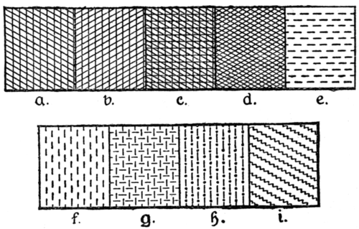
This Photo by Unknown Author is licensed under CC BY-SA

Try practising this technique in different ways. What do you notice?
- Try using pencils/pens that have a different thickness
- Try pressing lightly or harder on the paper
- Try doing lots of lines close together or lines further apart

PHYSICAL ACTIVITIES
Remember to look after both your physical and mental health. They are so important. You might enjoy our fitness fun challenge that you will find on the class pages as well. Have fun keeping fit and healthy.

Please look after yourselves and your family. Stay safe and we hope to see you all again very soon.
Miss Fojt and Miss Hugman

