YEAR 5 HOME LEARNING
Week Commencing 13th July
Thank you to everyone who has sent us photos of their work or emailed us letters to: learning@beechwoodprimaryschool.co.uk We are really impressed with how hard you are all working at home and we love seeing what you are doing.
Don’t forget to look at what everyone else is doing: www.beechwoodprimaryschool.co.uk/what-weve-been-doing-at-home

WEBSITES
https://www.bbc.co.uk/bitesize/tags/zhgppg8/year-5-and-p6-lessons/1
BBC Bitesize have an excellent range of daily lessons on lots of different subjects for your child to enjoy. New lessons are uploaded every day and include videos, practice activities, games and quizzes to help your child learn.
www.leedsforlearning.co.uk/Page/17071
Leeds for Learning have an excellent range of resources to help support home learning.

MATHS
The WhiteRose maths sheets are now on the school website (Go to the menu and click on Parents, Home Learning Support, Mathematics and Whiterose Maths Sheets.) The WhiteRose hub has teamed up with BBC Bitesize so that their content matches up. This means that you can find videos and additional worksheets on the Bitesize page to help with the learning on the WhiteRose sheets.
https://www.bbc.co.uk/bitesize/tags/zhgppg8/year-5-and-p6-lessons/1
For additional arithmetic and times tables practice please use these websites too:
Numbots – Years 2-6 - https://play.numbots.com/#/account/school-login/3913 - Use your TT Rock Stars username and password.
Maths Factor – All ages - https://www.themathsfactor.com/
Times Tables Rock Stars (Years 2-6) - https://play.ttrockstars.com/login/3913

SPELLINGS
You could also play games to practise the spellings and rules learned so far using www.spellingframe.co.uk .
The spellings to learn for this week are:
Year 5 statutory spellings

shoulder
pronunciation
thorough
bargain
available
interfere
immediately
existence
convenience
controversy

Please get someone to test you at the end of the week. Keep a record of your scores!

READING
Please keep reading at home! It is very important that you try and read at least 3 x per week.
Complete the book review sheet on the class page to tell us about a book you have read during your time at home.

ENGLISH
This week, you will be showing us your creative writing skills. Use your imagination to create and write a story based on the park bench image. The image and quick planning page are in a document on the class page. Follow the instructions and remember to include a subordinate clause, relative clause and fronted adverbial.
Take a photo of your finished story and email it to the learning email!

SCIENCE
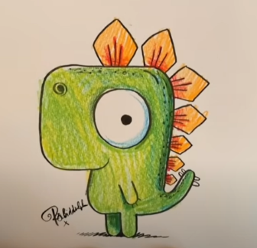
Look at the BBC Bitesize link to find out how animals adapt to their habitat. Watch the video and make some notes about the different ways animals change how they work to suit where they live. There is also a quiz to complete so let us know your score!
https://www.bbc.co.uk/bitesize/topics/zvhhvcw/articles/zxg7y4j

ART
This week practise your drawing skills with help from DRAW WITH ROB!
https://www.youtube.com/watch?v=bhyCxVPb1qU
His step by step video will help you draw a cartoon dinosaur. Give your dinosaur a fin name and send in a picture of it to the learning email!

PSHE

This week we would like you to write about your time in Year 5 and how you feel about going into Year 6. What were your favourite parts about being in Year 5? What did you enjoy doing? Which trips and activities did you like the most?
How do you feel about going into Year 6? What do you think will be different about being the oldest class in school? What are you looking forward to? Is there anything you have any worries about?
You could write this down as a diary entry, make a scrapbook of your favourite memories or just down on paper. Have a go at drawing some pictures to go with your writing! Despite the current situation we have had some wonderful experiences teaching you in year 2 and would love to hear about yours.
We would love to see what you are looking forward to and any worries you may have. Please send your work to the learning email: learning@beechwoodprimaryschool.co.uk
PHYSICAL ACTIVITIES
Remember to look after both your physical and mental health. They are so important.
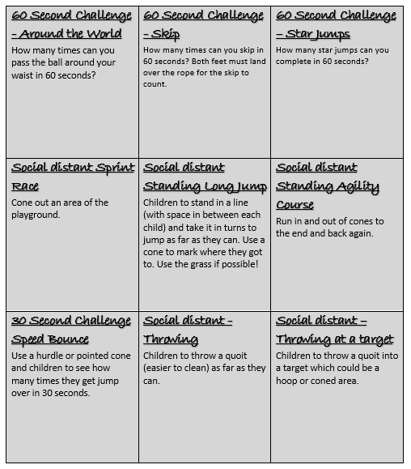

Thank you for all your hard work this term.

Please look after yourselves and your family and have a lovely summer.
Mrs Dunning Mrs Sturman Miss Warren

