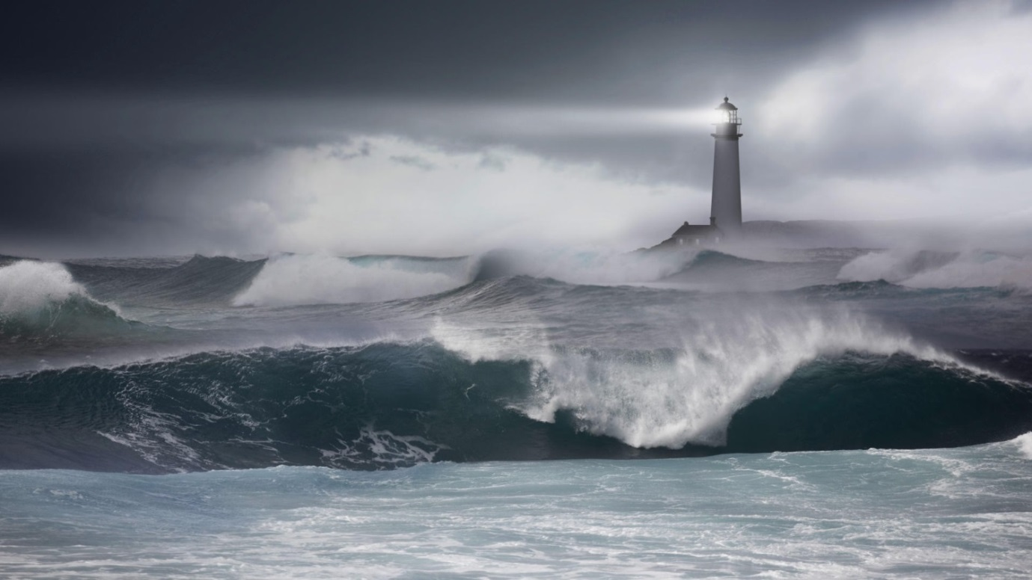
The Lighthouse

You will be writing a short story based on this picture.
Take a minute to think about how this image makes you feel and the type of story you want to write.

Before you write your story, answer the questions on your next page to give yourself a quick plan.

Then write you story. Use your imagination – this is your story!

Draft it first, edit it and remember to include a relative clause, subordinate clause and fronted adverbial.
Can you set the mood in your writing using detailed description and character’s emotions?
5 min plan
Write down as much as you can for each question in only 5 minutes!
Make notes…

What are the effects of this storm?

What time of day is it? What time of year is it?

Is there anyone there? Who are they? Where are they coming from? Where are they going? Do they have a name? Are you there?

What can be seen? Heard? Smelled? Tasted? Touched?

What happened before and after the picture was taken?

