YEAR 5 HOME LEARNING
Week Commencing 15th June
Thank you to everyone who has sent us photos of their work or emailed us letters to: learning@beechwoodprimaryschool.co.uk We are really impressed with how hard you are all working at home and we love seeing what you are doing.
Don’t forget to look at what everyone else is doing: www.beechwoodprimaryschool.co.uk/what-weve-been-doing-at-home

EXCITING NEWS!
Even though we are not all at school, some of Year 6 have been busy thinking about how we can still do Spirit Alive this year. Next week’s work pack will include information about how you can get involved with the fun while you are at home.

WEBSITES
https://www.bbc.co.uk/bitesize/tags/zhgppg8/year-5-and-p6-lessons/1
BBC Bitesize have an excellent range of daily lessons on lots of different subjects for your child to enjoy. New lessons are uploaded every day and include videos, practice activities, games and quizzes to help your child learn.
www.leedsforlearning.co.uk/Page/17071
Leeds for Learning have an excellent range of resources to help support home learning.

MATHS
The WhiteRose maths sheets are now on the school website (Go to the menu and click on Parents, Home Learning Support, Mathematics and Whiterose Maths Sheets.) The WhiteRose hub has teamed up with BBC Bitesize so that their content matches up. This means that you can find videos and additional worksheets on the Bitesize page to help with the learning on the WhiteRose sheets.
https://www.bbc.co.uk/bitesize/tags/zhgppg8/year-5-and-p6-lessons/1
For additional arithmetic and times tables practise please use these websites too:
Numbots – Years 2-6 - https://play.numbots.com/#/account/school-login/3913 - Use your TT Rock Stars username and password.
Maths Factor – All ages - https://www.themathsfactor.com/
Times Tables Rock Stars (Years 2-6) - https://play.ttrockstars.com/login/3913

SPELLINGS
The spellings to learn for this week are:
You could also play games to practise the spellings and rules learned so far using www.spellingframe.co.uk .
Year 5 statutory spellings
excellent
competition
ancient
individual
environment
opportunity
temperature
twelfth
signature
rhyme
Please get someone to test you at the end of the week. Keep a record of your scores!

READING
Please have a look at the free website below. Read Theory is a reading comprehension website where you take short quizzes to improve your comprehension skills. Create an account and take the pre-test to find texts that are suitable for you. Read Theory’s reading comprehension practice is adaptive and caters to the individual’s needs. It automatically recognises the student’s reading level and matches them with the appropriate text and questions https://readtheory.org/
Please keep reading at home! It is very important that you try and read at least 3 x per week.
These websites also have books to download / listen to:
Audible Books – Free audio books for all ages - https://stories.audible.com/start-listen
World Book – Free eBooks and audio books for all ages - https://worldbook.kitaboo.com/reader/worldbook/

ENGLISH
This week, you will be showing us your creative writing skills. Use your imagination to create and write a story based on the lake image. The image and quick planning page are in a document on the class page. Follow the instructions and remember to include a subordinate clause, relative clause and fronted adverbial.
Email your finished writing to the school email learning@beechwoodprimaryschool.co.uk – we would love to see what you come up with!

SCIENCE
This week, we are focussing on science. Our new topic is animals, their food chains and their habitats.
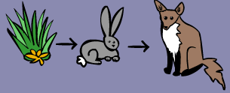
A food chain describes the order in which animals and plants are eaten. For example, a plant will be eaten by a rabbit then the rabbit will be eaten by a fox. There are different food chains in different habitats with all sorts of plants and animals relying on this cycle to survive.
Food chain activity
Complete the activity on BBC Bitesize about the food chain in woodland areas. Play the game to first, find a producer – a plant that makes its own food from sunlight. Next, find a consumer that eats the producer. Then, find another consumer that eats meat.
https://www.bbc.co.uk/bitesize/topics/zbnnb9q/articles/zsphrwx
Make notes on the videos about the different animals and create a poster about one of the animals. Have you seen any of the animals in real life? What did they look like? Tell us about this too!

Habitat activity
Use the search engine ‘Kiddle’ to research woodland habitats. Make a second poster about this habitat. Make sure to include scientific vocabulary. You could also present your posters to an adult in your household to show them the amazing facts you have found!
If you live near an area of woodland, you could explore it with your family and see if you spot any of the animals. Take a photo and send it to the learning email!

ART
If you live near a woodland area (or any area with trees), you could go with an adult and take paper and a pencil with you. Take your time to find a nice scene to sketch. Sit down and use your sketching skills to draw trees, flowers and anything else you spot.
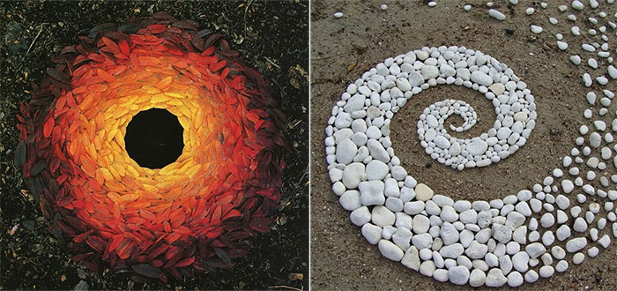
Andy Goldworthy is an artist who uses outdoor materials to create temporary artwork in outdoor places.

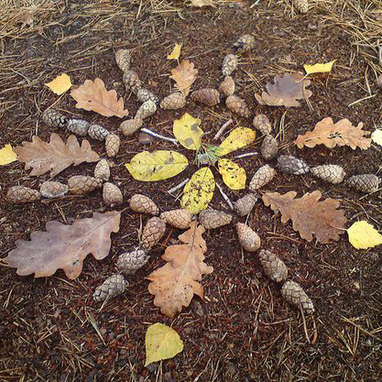
Have a go at creating your own version of outdoor art by finding materials such as pine cones, leaves, sticks and rocks and arranging them in a pattern. You could do a swirl or a circle based pattern. Here is an example of one made by other school children.

Send a photo of your artwork to the learning email!

PHYSICAL ACTIVITIES
Remember to look after both your physical and mental health. They are so important.
Go for a walk, bike ride or jog! You could play your favourite song and make a dance routine to it. If you have any other sports equipment, practise the sport and let us know what you have done.
These websites will also help you keep active:
- Body Coach – Jo Wicks live P.E. lesson at 9 am every day – (All ages) https://www.youtube.com/watch?v=K6r99N3kXME
- Cosmic Yoga – https://www.youtube.com/user/CosmicKidsYoga
- Stay Active – Premier Education Free activities to stay active at home - https://www.premier-education.com/stay-active/

Finally, don’t forget to take a look at the Oak National Academy. There are many subjects and topics that you could learn more about. Why not take a look and try out some of the lessons?
https://classroom.thenational.academy/subjects-by-year/year-5/
We hope you can complete many of these activities throughout the week and really look forward to seeing all your hard work!

Please look after yourselves and your family and we hope to see you all again very soon.
Mrs Dunning Mrs Sturman Miss Warren

