Spring Term
History
Learning Grid for
Year 2

Explorers
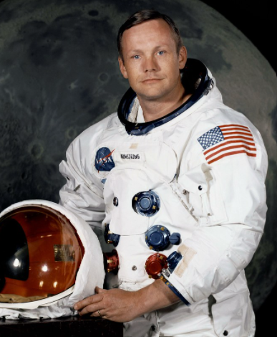
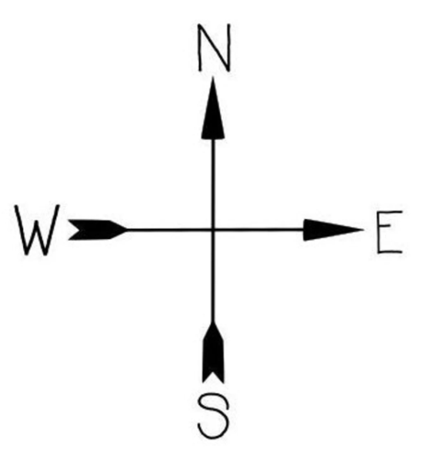
Topic Vocabulary
Explorer- An explorer is someone who travels to places which very little is known to discover what it is like there.
Explore- If you explore a place you travel around it to find out what it is like.
The Solar System – The Solar System is the sun and all the planets that go around.
The moon – the moon is the object that you can often see in the sky at night. It goes round the Earth once every four weeks.
A planet -a planet is a large, round object in space that moves around a star. The Earth is a planet.
Astronaut- an astronaut is a person who is trained for travelling in a spacecraft.
Pilot- A pilot is a person who is trained to fly an aircraft like an aeroplane or helicopter.

History Facts to learn
On 16th July, 1969, Neil Armstrong, Buzz Aldrin and Michael Collins launched into space and Neil Armstrong was the first man to step on the moon on 20th July.
On 12th October, 1492, Christopher Columbus spotted a small island in the Bahamas that he named San Salvador. When he returned, he brought back some of the things he had found such as pineapple.
In May 1932, Amelia Earhart became the first woman to fly solo across the Atlantic Ocean. Sadly, on 2nd July, due to bad weather and low fuel, they tried to land but they never made it.

Useful Weblinks
https://www.esa.int/kids/en/learn/Our_Universe/Planets_and_moons/The_Solar_System_and_its_planets
https://www.bbc.co.uk/bitesize/topics/zhpchbk

Home Learning Challenge Ideas
Can you create a poster, poem or fact file to show what you have learned about The Solar System?

Can you make your own map?
It could be a map of a real place like your street or an imaginary land that you invent.

Can you find out about an explorer you are interested in and make a poster to show what you have learnt?

We would love to see any of your own topic work that you choose to do at home so you might do something completely different. We are looking forward to sharing it together and displaying it on the Beechwood Website.

