Topic Vocabulary
Traditional Tale: A well-known story that has been told for a very long time. They usually teach us an important lesson.
Character: Someone in a story. In a traditional take it could be a princess, prince, talking animals, wicked stepmother, giants or witches.
Plot: The series of events in a story which may start with ‘Once upon a time’ and end with ‘happily ever after’.
Setting: Where a story takes place. In a fantasy story it could be in a castle, a forest, under the sea or in a cave.
Villain: an evil character

Hero: A character who is brave, kind and helps others.

Spring term 1-
Traditional Tales

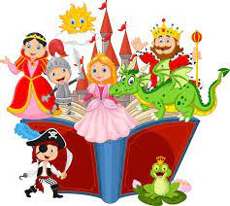

Facts to learn:
Traditional tales usually start with ‘Once upon a time…’ and end with ‘Happily ever after.’
Here are some words that you will use when retelling stories to put events in order:
First Next After that Last
Traditional tales have made up (fictional) characters, creatures and talking animals that are different to people in our real lives. Here are some of the names of the main characters:
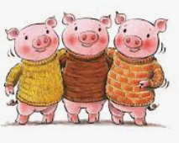
Three Little Pigs Little Red Riding Hood Gingerbread Man

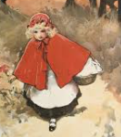
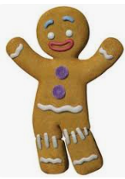
Useful Weblinks
EYFS Listen and Play; Traditional Stories
Mr Tumble Tales
School Learning Zone: Once Upon A Time

Home Learning Challenge Ideas
Can you create a wanted poster for the wolf?
Can you make your own story map for one of your favourite traditional tales?
Can you build a house for the Three Little Pigs?
Can you make porridge for the Three Bears from Goldilocks?
Can you plant a bean seed like Jack?
What is your favourite traditional tale? Have a go at drawing a picture of it.

We would love to see any of your own topic work that you choose to do at home so you might do something completely different.
Please share your home learning with us on Tapestry!

