Remembrance Day
Remembrance Day is on the 11th of November. We wear red poppies. We remember people who went to war. We have a quiet moment to say thank you.

Diwali
Diwali is the Festival of Lights.
People light candles called diyas.
Families eat sweets and give gifts. It is a special time for Hindu people.

Topic Vocabulary
Celebration: A special time when people are happy and do something fun together.
Birthday: The day each year when someone gets a year older.
Party: A fun time with games, music, and treats!
Gathering: When people come together to see each other.
Anniversary: A day each year to remember something special that happened.
Wedding: A special day when two people get married.
Fireworks: Bright lights and colours that go boom in the sky!

Autumn term 2-
Celebrations

Facts to learn:

Home Learning Challenge Ideas
Can you create your own firework painting for Bonfire Night?
Can you act out the Christmas story at home or draw it using pictures?
Can you create your own simple Rangoli patterns for Diwali?
Can you make a poster or booklet to show something special you celebrate in your family e.g. birthday, wedding, cultural festival? Can you tell us how you celebrate?

We would love to see any of your own topic work that you choose to do at home. You might do something completely different to these ideas.
Please share your home learning with us on Tapestry!

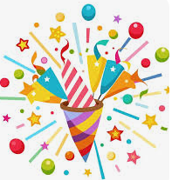
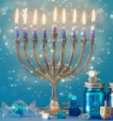
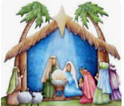
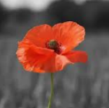
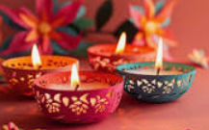
Hanukkah
Hanukkah is a Jewish festival. It lasts for 8 nights. People light a special candle each night.
Families eat yummy food and play games.

Christmas
Christmas is on the 25th of December. It is a special time for Christians. People give presents and decorate trees. They celebrate the birth of baby Jesus.

Useful Weblinks
What is Diwali?
Christmas Story
What is Hanukkah?
Why Do You Like Celebrating?

