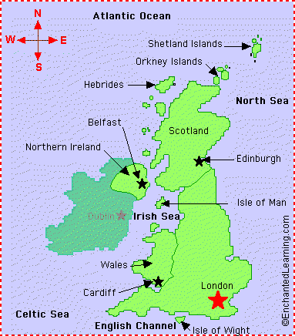
Important Vocabulary
world – the planet we live on
country – a part of the world covering a particular area of land
sea – a large area of salty water that is part of an ocean
ocean – a large area of water
map – a drawing of a particular area such as a city, country or continent showing its main features from above.
landmark – important feature or building
globe – ball shaped object with a map of the world on it
atlas – book of maps
Pole – parts of the world at the top (North) and bottom (South) of the Earth’s axis.
Equator – an imaginary circle around the Earth that divides it into two equal parts.
Weather – the condition of the atmosphere at a certain time e.g. windy, rainy, sunny.
Climate - the climate of a place is the general weather conditions.

Year 2 - Geography
Explorers

a

The country I live in is England.
The city I live in is Leeds. Seacroft is part of Leeds.
England is a country that is part of the United Kingdom.
The four countries in the United Kingdom are: England, Wales, Scotland and Northern Ireland
The capital city of England is London.

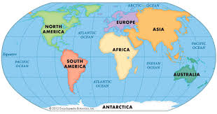
There are seven continents and five oceans on a world map.

Continents Oceans
Europe Pacific Ocean
Asia Atlantic Ocean
Africa Indian Ocean
North America Arctic Ocean
South America Southern Ocean
Australia
Antarctica

The equator is an equal distance from the North and the South Pole.
The equator is closest to the sun. The closer you get to the equator, the hotter it will be. The further away from the equator, the colder it will be.
The North and South Poles are the coldest places on Earth because they are far away from the equator and don’t get direct sunlight.
The South Pole is much colder than the North Pole because it is surrounded by the Antarctic Ocean.

Human and Physical Geography
Human features are things in the environment that are made by humans (man-made).

Physical features are things in the environment that are created by nature.


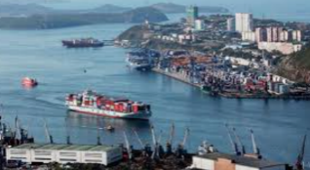


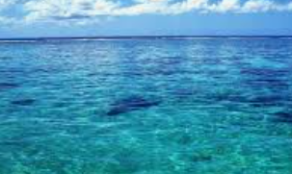
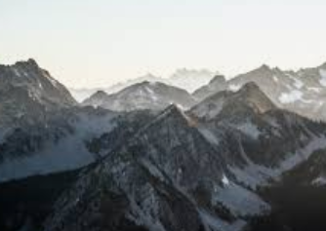
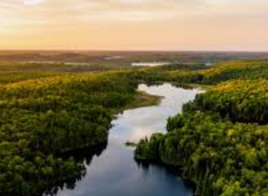
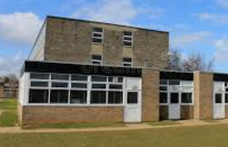
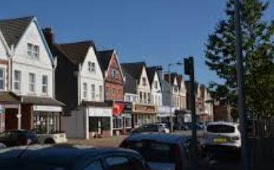

shop
town
school
port
house
city

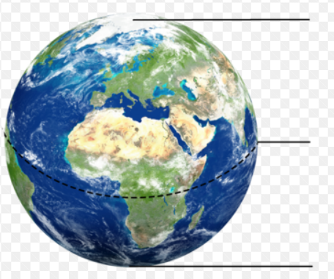
North Pole
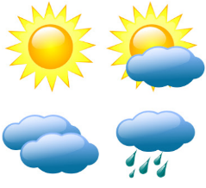

equator
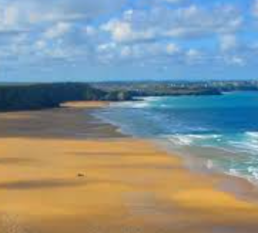
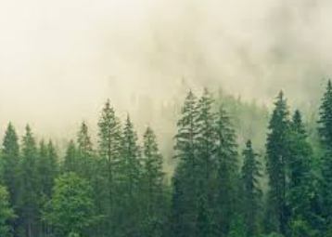
beach
forest
weather
ocean/sea
mountain
river
South Pole

