Year 2 Explorers
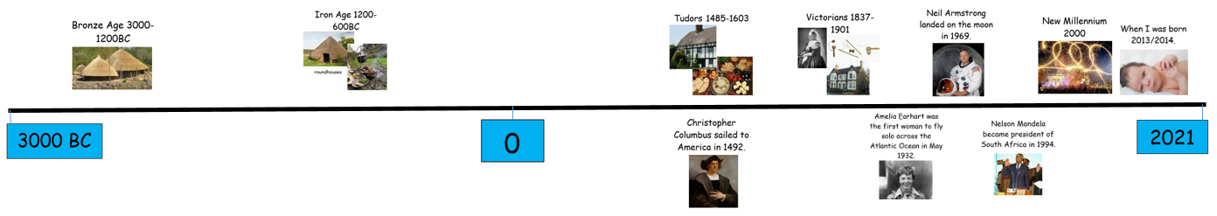

Why do people explore?
Most explorers like the adventure of going to a new place, meeting new people and taking on a new challenge. Some explorers go and find new trade partners and goods. Other explorers have searched for gold, silver and treasure. Lots of scientists explore to find out about natures of new parts of the world. Many explorers claimed the land they found in the name of their country. Also, some explorers like a challenge and what to be the first in the world to do something.

Christopher Columbus
Christopher Columbus was born in Genoa, Italy in 1451. He worked as a trader and learned to make maps and navigate ships. He knew there were great riches in China so he wanted to find a way to get there. He set sail on August 3, 1492 with three ships and the voyage was long and difficult. On 12th October, 1492, he spotted a small island in the Bahamas that he named San Salvador. When he returned, he brought back some of the things he had found such as pineapple.

Read more at: https://www.ducksters.com/biography/explorers/christopher_columbus.php
This text is Copyright © Ducksters. Do not use without permission.

Neil Armstrong
Amelia Earhart
Amelia was born in July 1897 in Kansas, America. She started flying when she was 23 years old. In 1921, she bought her own plane and in 1923, she got her pilot’s licence. She spent many years taking part in joint flights and trips but in May 1932, she became the first women to fly solo across the Atlantic Ocean. On 20th May 1937, Amelia and her guide started a trip around the world. Sadly, on 2nd July, due to bad weather and low fuel, they tried to land but they never made it. A lighthouse was built to remind people of Amelia.

Neil Armstrong was born on 5th August 1920 in Ohio, America. He became interested in flying from an early age and earned his pilot’s licence at 16. He went onto study aeronautical engineering at University and then served in the Korean War as part of the Navy. Neil Armstrong left the Navy a few years later and joined NASA where he became a test pilot and even tested the X-15 which was a high-speed aircraft. On 16th July 1969, Neil Armstrong, Buzz Aldrin and Michael Collins launched into space and on 20th July, Armstrong landed the Lunar Module on the moon’s surface. He said “That's one small step for man, one giant leap for mankind," as he made his famous first step on the moon.

Important vocabulary


