
Spring Term 2 2026
Phonics Newsletter
Every week, your child in working hard in their daily phonics lessons using the Read Write Inc scheme. Please follow the links or scan the QR code for your child’s group and keep accessing this over the half term to support your child at home.
How do I use the virtual classroom?
- Set aside 10 minutes to watch a film with your child each day (links below).
- Find a quiet space for your child to watch the film on a laptop or tablet.
- Praise your child as they join in with the lesson – make it fun!

Group | Virtual Classroom Links and QR codes
Blending group  Miss Tobin | 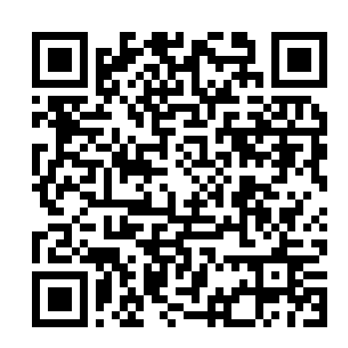  https://schools.ruthmiskin.com/resources/vc-pathways/324706/Myb5nhMzPC06Za7m
Ditty  Mrs Williamson/Mrs Matharoo | 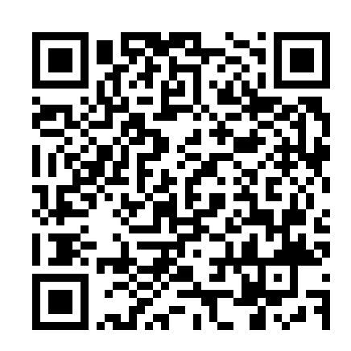  https://schools.ruthmiskin.com/resources/vc-pathways/361443/3KEHmVG82TRLPjIw
Red  Miss Scrivens | https://schools.ruthmiskin.com/resources/vc-pathways/361449/2Ek0sXKbmpgQrpTJ  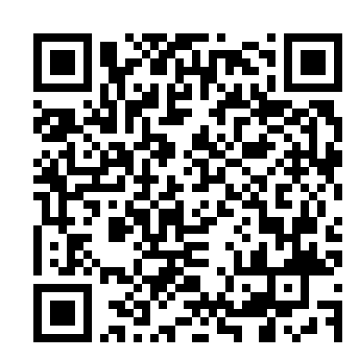
Green  Mrs Ilsley | 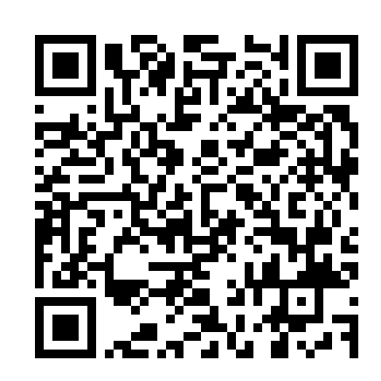  https://schools.ruthmiskin.com/resources/vc-pathways/361453/FLQpP1D0qmR46kaF
Purple  Miss Riley | https://schools.ruthmiskin.com/resources/vc-pathways/361461/JeZ97QMyToZG1bb7  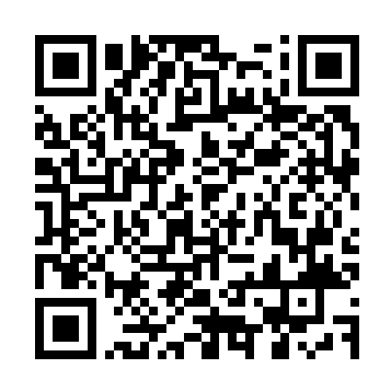
Pink  Mrs Mulvihill | https://schools.ruthmiskin.com/resources/vc-pathways/361467/fKuRLHxHmDs8xel8  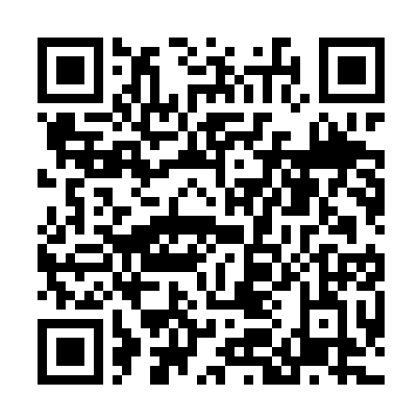
Orange  Miss Collins | https://schools.ruthmiskin.com/resources/vc-pathways/361473/TAX6UtSOF5Am3nEE  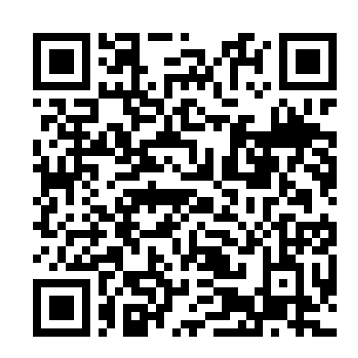
Yellow  Mrs Merritt  Mrs Powley | 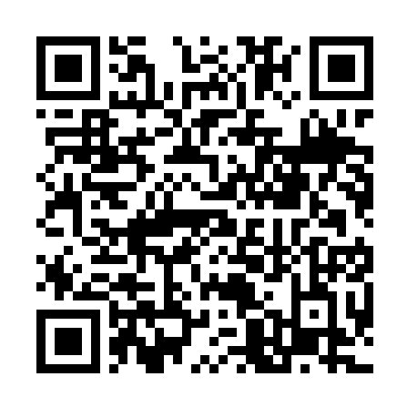  https://schools.ruthmiskin.com/resources/vc-pathways/361479/qNw6Jcsyi4Fo6JG0
Blue  Mrs Taylor | https://schools.ruthmiskin.com/resources/vc-pathways/325431/23WKY8mTw7JYfc2t  

