
Spring Term 1 2026
Phonics Newsletter
Every week, your child in working hard in their daily phonics lessons using the Read Write Inc scheme. Please follow the links or scan the QR code for your child’s group and keep accessing this over the half term to support your child at home.
How do I use the virtual classroom?
- Set aside 10 minutes to watch a film with your child each day (links below).
- Find a quiet space for your child to watch the film on a laptop or tablet.
- Praise your child as they join in with the lesson – make it fun!

Group | Virtual Classroom Links and QR codes
Blending group  Miss Tobin | 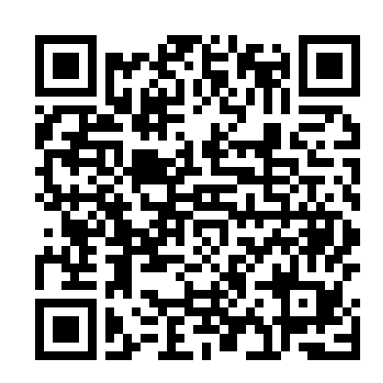  http://schools.ruthmiskin.com/resources/vc-pathways/324706/Myb5nhMzPC06Za7m
Ditty  Mrs Hunter | 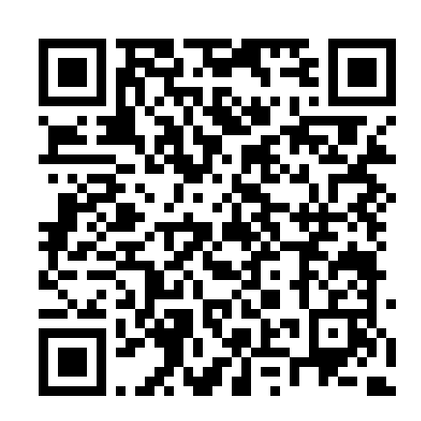  http://schools.ruthmiskin.com/resources/vc-pathways/325420/dpdCED9R0NjULCg0
Red  Miss Scrivens | 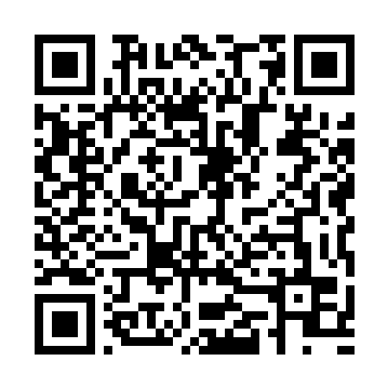  http://schools.ruthmiskin.com/resources/vc-pathways/325421/bzToJjFeNc4hj40M
Green  Mrs Ilsley | 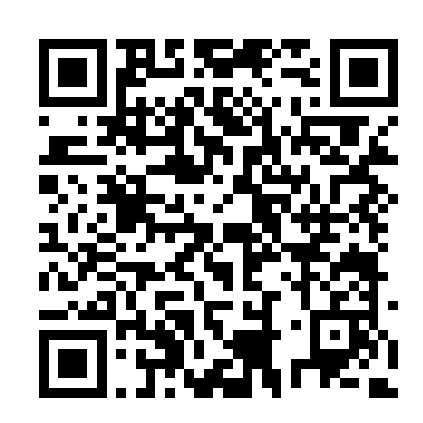  http://schools.ruthmiskin.com/resources/vc-pathways/325422/wTHeyUexsLX0vJVr
Purple  Miss Riley | http://schools.ruthmiskin.com/resources/vc-pathways/325423/Qv5tFBZl1Cix7suQ  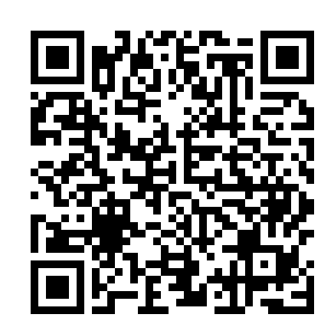
Pink  Mrs Mulvihill | http://schools.ruthmiskin.com/resources/vc-pathways/325424/g07M59sf0oeGaH8Z  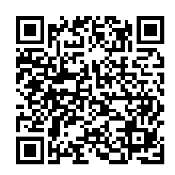
Orange  Miss Collins | 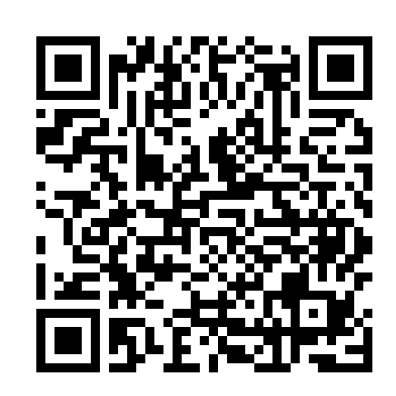  http://schools.ruthmiskin.com/resources/vc-pathways/325426/RvkvBab6n4TcKA4o
Yellow  Mrs Merritt  Mrs Powley | http://schools.ruthmiskin.com/resources/vc-pathways/325428/ZKT0MLqZeVUoxy2i  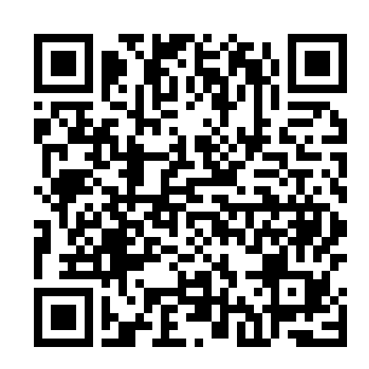
Blue  Mrs Taylor | http://schools.ruthmiskin.com/resources/vc-pathways/325431/23WKY8mTw7JYfc2t  

