rnrney
Topic Vocabulary
Fantasy story: A story about magical people or beings who may live in a magical or unusual place.
Imagination: Forming a picture in your mind of something that you have not seen or experienced.
Character: Someone in a story. In a fantasy story it could be a princess, dragon, alien, mermaid or wizard for example.
Plot: The series of events in a story which may start with ‘Once upon a time’ and end with ‘happily ever after’.
Setting: Where a story takes place. In a fantasy story it could be in a castle, a forest, under the sea, in a cave.
Spring term 1:
Fantasy Worlds

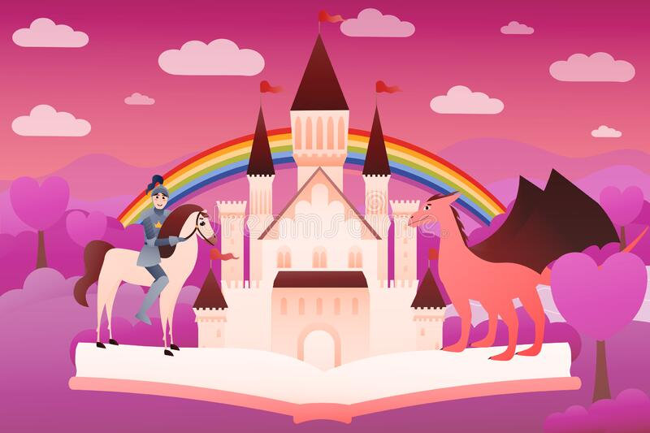
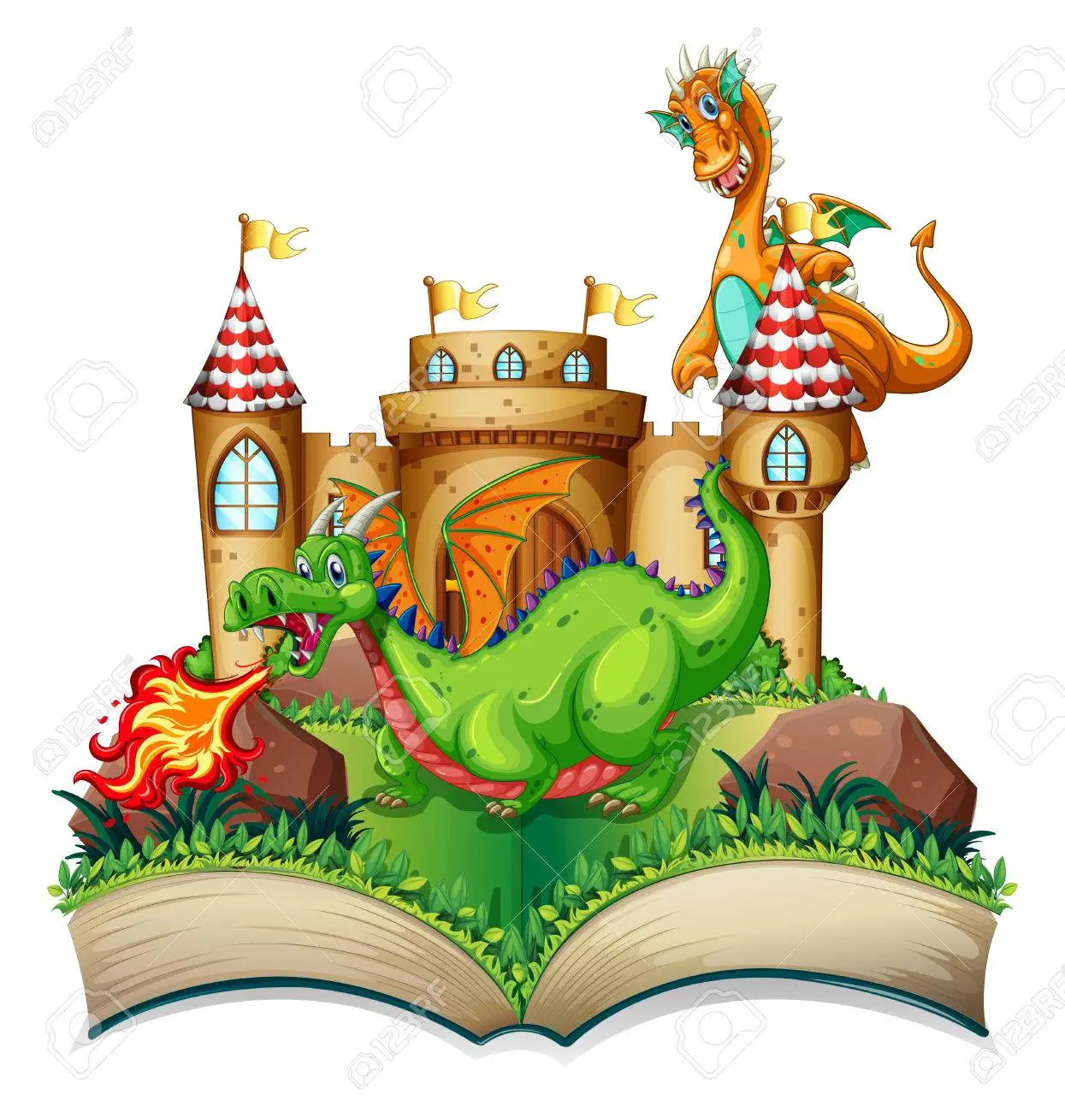
Facts to learn
Children will learn:
How stories are sequenced.
How different characters act in stories.
Where stories may happen.
How to retell a story.
How to use their imagination to make up or act out stories.
Children will read stories including:
Zog
Zog and the Flying Doctors
The Magic Painbrush
We’re Going on a Dragon Hunt
The Princess and the Wizard

Home Learning Challenge Ideas

- Can you draw a picture of your favourite character from a fantasy story?
- Make a model castle. You could use cardboard boxes and tubes, building bricks or empty packaging
- .Can you decorate a crown for a prince or princess?
- Go for a walk or into your garden to collect natural materials. Use them to create a fairytale woodland.
- Go on a visit to your local library. Can you find any books about castles, princesses, knights or dragons? You might find some storybooks or some information books. Which book is your favourite?
We would love to see any of your own topic work that you choose to do at home so you might do something completely different.
Please share your home learning with us on Tapestry!

Useful Weblinks
There Was A Princess - Music Bus
BBC iPlayer - Zog
BBC iPlayer - Zog and the Flying Doctors
The Princess and The Pea - CBeebies - BBC
Cracker The Dragon Of Wonder | A Cosmic Kids Yoga Adventure! - YouTube

