Nursery Newsletter
Fantasy Worlds
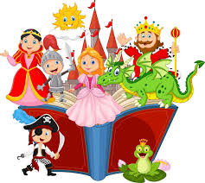

This half term we will be learning all about ‘Fantasy Worlds’ in Nursery. We will be learning about what fantasy means and exploring what characters, stories and plots we enjoy. Children will be using their imagination to create make believe characters who go on an exciting journey through some amazing places. Some of these characters will be based on stories we have shared together. The main characters we will be focusing on are pirates, aliens, superheroes, princesses and princes, mermaids and monsters.
This half term we will start our Stay and Play sessions after the new children have settled in. The Stay and Play sessions will be Wednesday 22nd January and Wednesday 5th February. There will be one session at 9am and one session at 2.30. Please continue to bring your child to their normal session on the Wednesday. One parent or guardian is invited to join us for one of the sessions for fire safety reasons.
Please also use Tapestry to upload any ‘wow’ moments your child has at home.

Thank you for your continued support,
The Nursery team.

