Nursery blog

Nursery have had a wonderful week back. They have enjoyed talking to their friends about their break. We have been very excited to meet our new friends who will be joining our nursery. Children have been talking about our new topic 'Fantasy' and have been interested in exploring our alien and elf village areas. We have been enjoying our new stories in the book corner too.

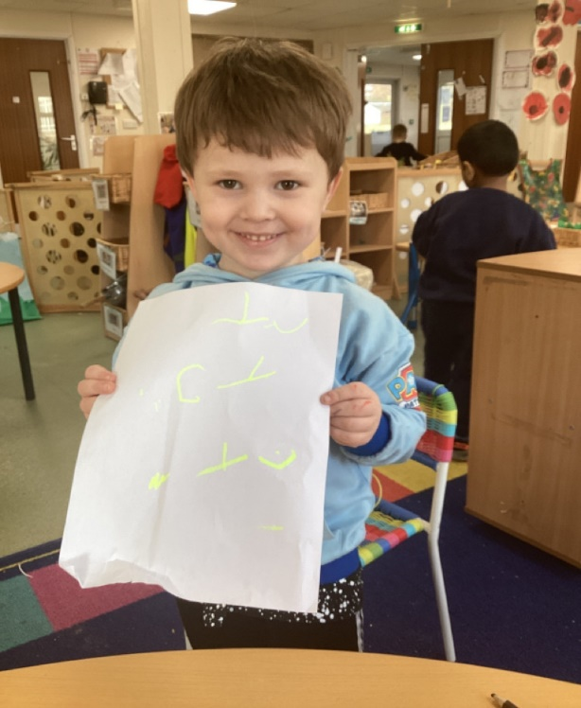
All children in Nursery received a class certificate to say well done for coming back into Nursery so well and for being so kind to our new children.


