With an adult, help bake or cook your favourite food. | 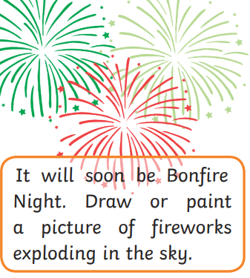  Reception Half Term Challenge!  When you complete a challenge, colour the box in. Can you complete them all? Upload a picture on Tapestry for us to see! | 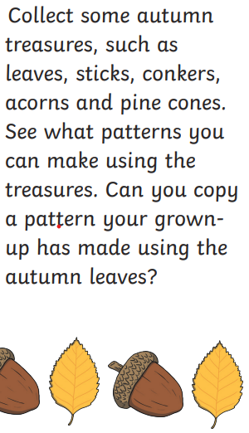
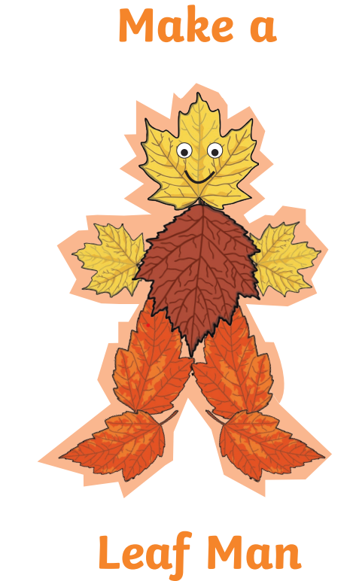
Take some photographs of signs of Autumn. | Dress up for Halloween. Maybe go Trick or Treating. | Practice your handwriting

