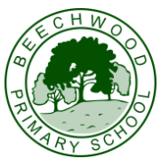

Reception Newsletter and Home Learning
27th October 2023

Phonics: Read Write Inc (RWI)  We have learnt how to say and write the sounds  r, j, v, y  In addition to: m, a, s, d, t, i, n, p, g, o, c, k, u, b, f, e, l, h, sh,  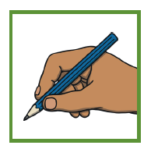  We are practising writing the sounds above in handwriting too and trying hard to hold our pencil correctly in the tripod grip | Maths Learning:  In Monday Maths, we have been continuing to look at patterns including repeating patterns:  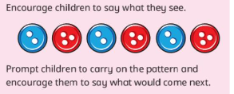  Can you make repeating patterns at home? Take a photo and upload them onto tapestry!
Reading at home And Reading Books
Reminder: books are changed on a Friday. Please record reading at home in the planner with a reading comment.
Topic
We have been learning the song ‘Power in Me’ and reading the book I am Enough by Grace Byers. We have talked about being resilient and persevering, and that ‘We are Enough!’ We thought about what we want to be when we grow up too.
Thank you to all that attended our Black History Month Assembly – the children we very proud of themselves.
.Reminders / Dairy Dates:
Please name all uniform/coats/gloves over the half term holidays
Monday 6th November: Teacher Training day. School is closed to pupils.
Tuesday 7th November: School is back open to pupils.
We hope you have a safe and fun half term. Please have a go at our half term challenge and bring it in to show us on Tuesday!
Thank you. The Reception Team. 😊

