Geographical Facts to Learn
The country I live in is England.
The city I live in is Leeds. Seacroft is part of Leeds.
England is a country that is part of the United Kingdom.
The four countries in the United Kingdom are: England, Wales, Scotland and Northern Ireland
The capital city of England is London.
Begin to learn the names of the seven continents.
Continents
Europe
Asia
Africa
South America
North America
Australia
Antarctica

Topic Vocabulary
world – the planet we live on
country – a part of the world covering a particular area of land
ocean – a large area of water
map–a drawing of a particular area such as a city, country or continent showing its main features from above.
globe – ball shaped object with a map of the world on it
Continent - one of the earth's seven major areas of land.

Summer Term
Geography
Learning Grid for
Year 1

Houses and Homes around the World
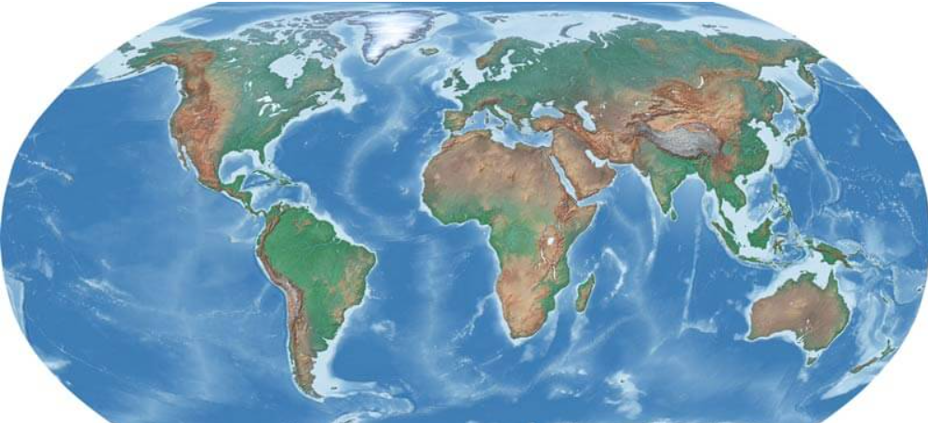

Useful Weblinks
https://kids.kiddle.co/House
https://www.kidcyber.com.au/houses-around-the-world
https://www.theschoolrun.com/homework-help/houses-and-homes

Home Learning Challenge Ideas
Draw a picture of your house.
What kind of homes are there in Seacroft? Can you do a simple map showing these homes?

Find out about different homes around the world and…
- Make your own mini book
- Make a model of one of the homes
- Write about one of the homes
- Draw a picture of do a collage of one of the homes
- Make an amazing poster of homes around the world

Please could your child bring in anything they do at home. They can share it with their class and we can show it on the school website.

