Summer Term
History
Learning Grid for
Year 1

Houses and Homes around the World
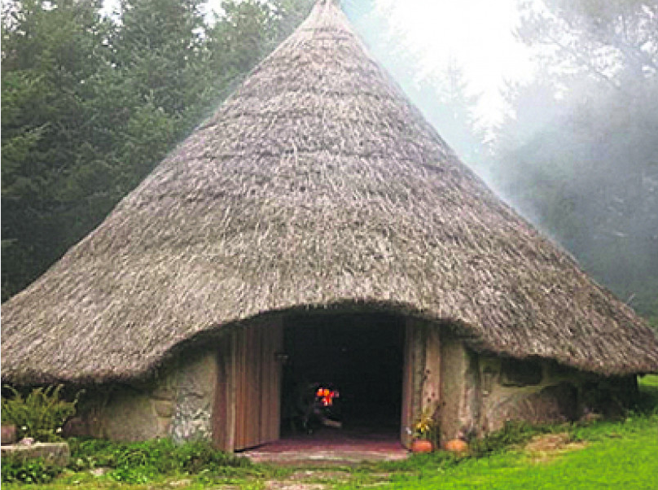

Historical Facts to Learn
Houses tell us something about the people who built them and the times in which they lived.
Houses from the past have similarities and differences to houses today.
People used to live in caves but over time they learned to build their own shelters, and then homes.
The Celtic tribes built roundhouses made from wood and straw, stuck on with mud.
The Tudor houses were made from wood and the spaces in between were filled using small sticks and wet clay.
In Victorian times people could build their houses using materials from anywhere.

Important Vocabulary
Before
at an earlier time; in the past
After
later in time
In the past
gone by in time
Now
at this time
Last year
a year ago.
This year
From January
A long time ago
far in the past
Different
not the same
Changed
to become different
Similar
having a likeness

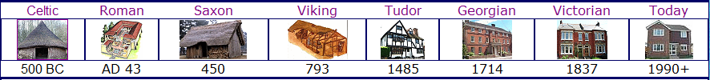

Home Learning Challenge Ideas
Places to visit to learn about homes in the past…
Abbey House Museum
York Castle Museum
Seacroft Village. There is lots of history to see in the village. Look out for the QR codes to find out more about different properties.

Make a home from the past
Draw a home from the past
Do a collage of a home from the past
Write about a home from the past
Please could your child bring in anything they do at home. They can share it with their class and we can show it on the school website.

Useful Weblinks
https://classroom.synonym.com/types-houses-through-ages-kids-8015479.html

http://www.primaryhomeworkhelp.co.uk/houses.html
http://www.ls14trust.org/seacroft-history.html

