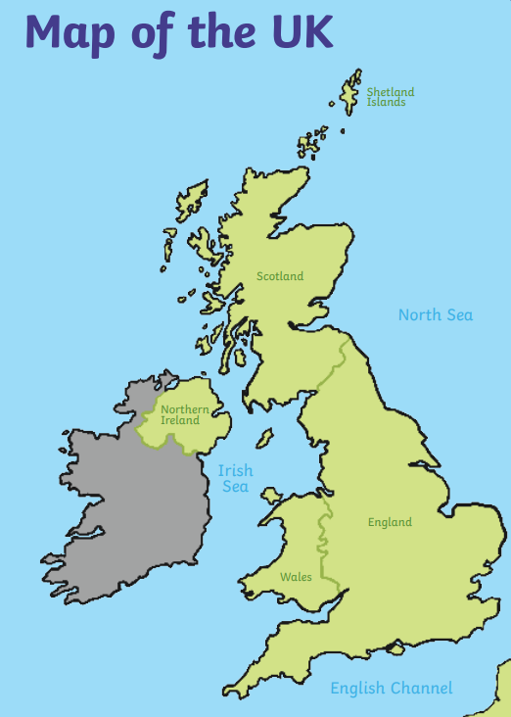
Food of all Nations
Year One
Geography Knowledge Mat
Important Vocabulary
world – the planet we live on
country – a part of the world covering a particular area of land
sea – a large area of salty water that is part of an ocean
ocean – a large area of water
human features – feature in the environment that is made by humans
physical features – feature that was created by nature
map–a drawing of a particular area such as a city, country or continent showing its main features from above.
globe – ball shaped object with a map of the world on it
atlas – book of maps
home- where a person lives
Continent - one of the earth's seven major areas of land.
Place - where things are or where people live or work
Equator –an imaginary circle around the Earth that divides it into two equal parts.

The country I live in is England.
The city I live in is Leeds. Seacroft is part of Leeds.
England is a country that is part of the United Kingdom.
The four countries in the United Kingdom are: England, Wales, Scotland and Northern Ireland
The capital city of England is London.

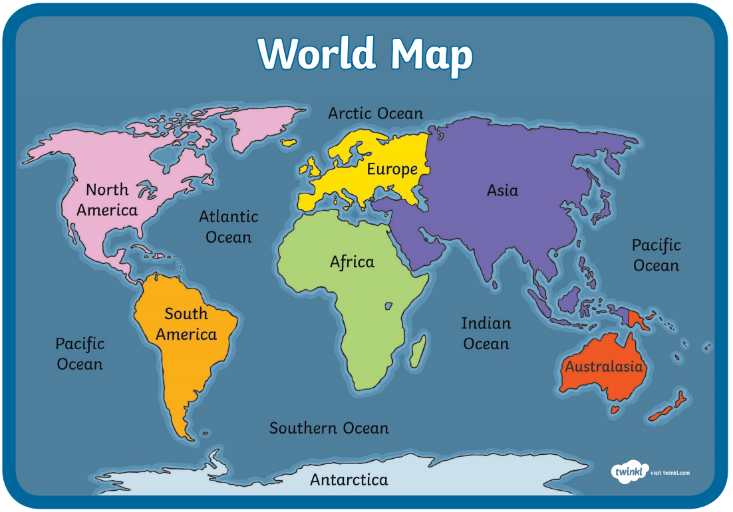
There are seven continents and five oceans on a world map.

Continents Oceans
Europe Pacific Ocean
Asia Atlantic Ocean
Africa Indian Ocean
North America Arctic Ocean
South America Southern Ocean
Australia
Antarctica

Human and Physical Geography
Human features are things in the environment that are made by humans (man-made).

Physical features are things in the environment that are created by nature.
Equator –an imaginary circle around the Earth that divides it into two equal parts. Places close to the equator are hotter.
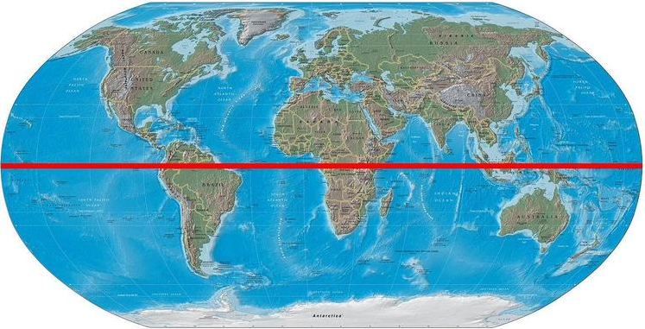
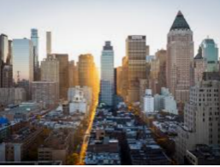

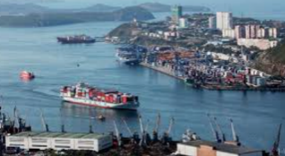
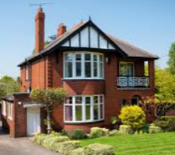

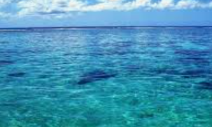
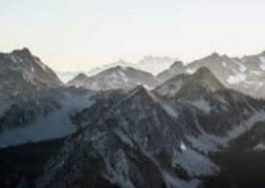
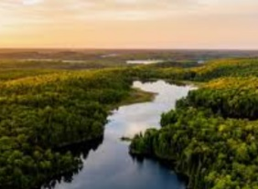
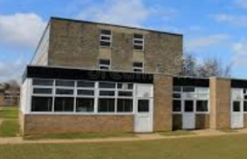
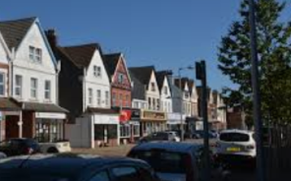

shop
town
school
port
house
city

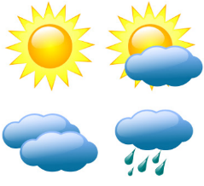
There are four seasons in a year and the weather can change in each season.
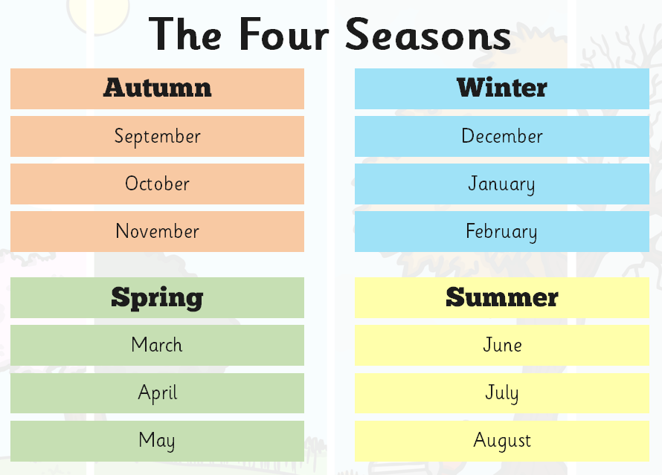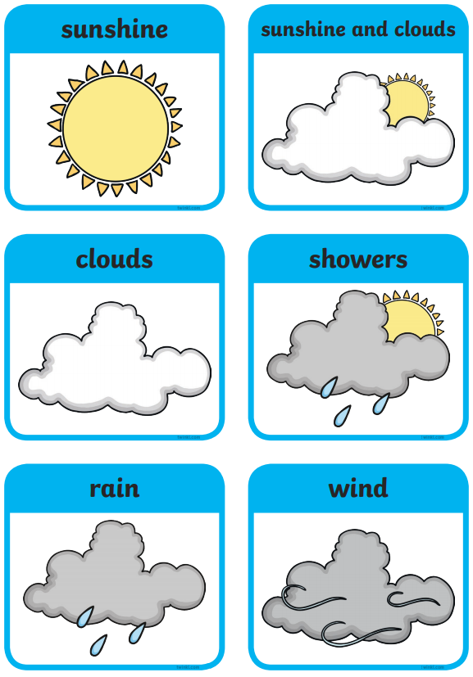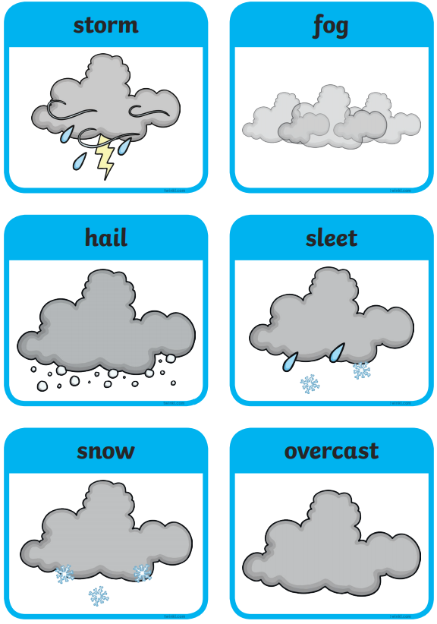

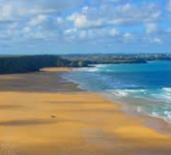
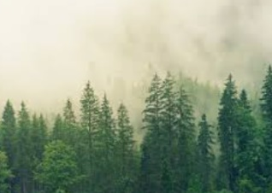
beach
forest
weather
ocean/sea
mountain
river

