Historical Facts to Learn
- History means things that have happened in the past.
- Toys were mainly made out of wood, paper or metal during Victorian times.
- Rich Victorian children played with toys such as clockwork trains, rocking horses, tea sets and dolls.
- Poorer children played with homemade toys such as peg dolls, wooden boats and rags stuffed with sawdust to make balls or toy animals.

Topic Vocabulary
Before - at an earlier time; in the past
After -later in time
In the past - gone by in time
Now - at this time
Last year - a year ago
This year - From January
A long time ago -far in the past
Different - not the same
Changed - to become different
Similar - having a likeness

Autumn Term
Learning Grid for
Year 1

Who am I?
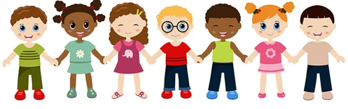

Home Learning Challenge Ideas

Please could your child bring in anything they do at home. They can share it with their class and we can show it on the school website.

- Interview a grandparent – What do they remember about being a child? Ask them about their favourite toy? What was school like?
- Postcard – Create a postcard from a holiday or day out you remember. Draw a picture from your memory.
- Toys from the past – bring in a toy from the past. This could belong to you or your parent or even a grandparent.
- Family tree – make a family tree to show how your family fits together. This could be a drawing, craft or using real tree parts and photographs!
- Game time – play a board game or outdoor game from that past which does not involve a screen.
- Timeline – Use a range of photos from birth to now to create a timeline.
Useful Weblinks
https://school-learningzone.co.uk/key_stage_one/ks1_history/toys_in_the_past/toys.html

https://learnenglishkids.britishcouncil.org/category/topics/toys

https://www.theschoolrun.com/homework-help/history-toys

