Key Vocabulary
circulatory system | A system which includes the heart, veins, arteries and blood transporting substances around the body.
heart | An organ which constantly pumps blood around the circulatory system.
blood vessels | The tube-like structures that carry blood through the tissues and organs. Veins, arteries and capillaries are the three types of blood vessels.
oxygenated blood | Oxygenated blood has more oxygen. It is pumped from the heart to the rest of the body.
deoxygenated blood | Deoxygenated blood is blood where most of the oxygen has already been transferred to the rest of the body.
organ | A part of an organism which has a specific function
blood | The red liquid that circulates in the arteries and veins of humans and other vertebrate animals
respiratory system | The network of organs and tissues that help you breathe
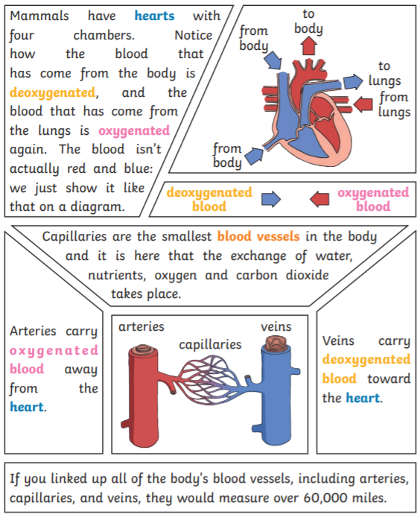
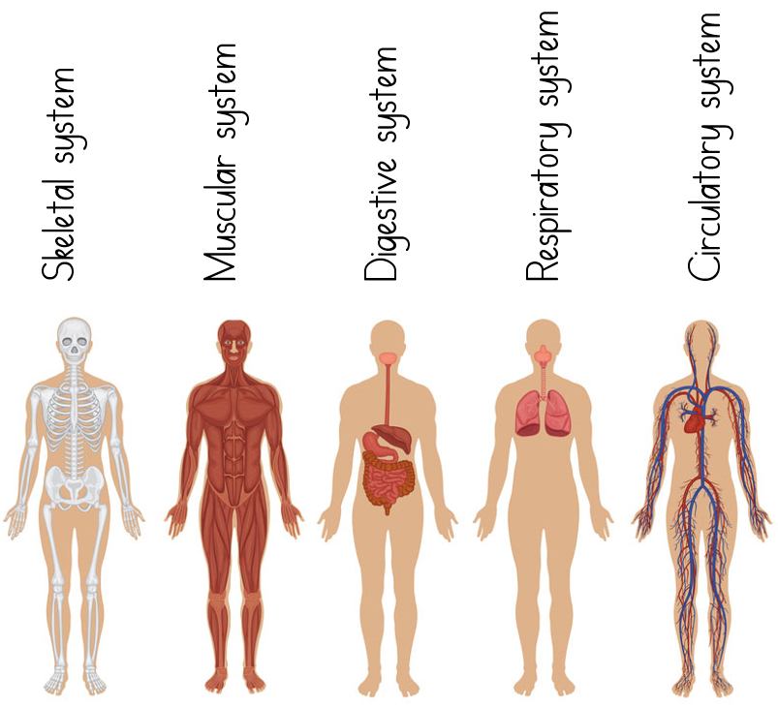
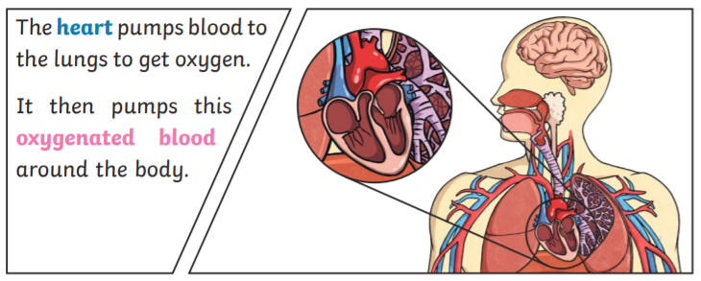
Useful websites
www.kiddle.co
www.bbc.co.uk/bitesize/topics/zcyycdm
www.ducksters.com/science/biology/humanbody.php

the heart
arteries, veins and capillaries
different systems in the body
the circulatory system and heart
Autumn Term
Science Learning Grid
Year 6

Systems in the Body

Home learning challenge ideas
Create a drawing or model of how the heart works. Research it first to make it scientifically accurate.
Make your own blood soup! We will do this in a science lesson – could you do something similar using different things to represent the parts of the blood?
Make a poster explaining the differences between arteries and veins.
Choose one of the systems in the body (skeletal, muscular, digestive, respiratory, circulatory) and create a fact file or presentation about it.
We would love to see any of your own topic work that you choose to do at home so you might do something completely different. We are looking forward to sharing it together and displaying it on the Beechwood Website.
Facts to learn
The heart pumps blood to the lungs to get oxygen. It then pumps this oxygenated blood around the body.
Mammals have hearts with four chambers. The blood that comes from the body is deoxygenated and the blood that comes from the lungs is oxygenated.
Blood is made up of plasma, red blood cells. white blood cells and platelets.
If you linked up all of the body’s blood vessels they would measure over 60,000 miles.

