rnrney
Summer term 1-
Plants and Animals

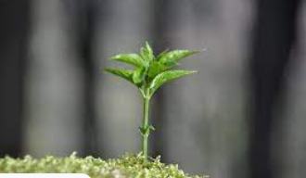
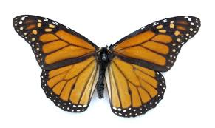
Facts to learn:
These are the things plants need to grow:

sunlight water soil air space to grow
Here are some of the things you might use to grow a plant:
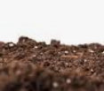
soil watering can seeds plant pot spade
Fruits and vegetables can grow under the ground or on trees.

Topic Vocabulary
Fruit: grows from a seed and can be eaten.
Vegetable: a plant or part of a plant used as food.
Animal: a living thing that is not a human or plant that need food and water to live.
Plant: a plant or part of a plant used as food.
Grow: To become larger by natural development.

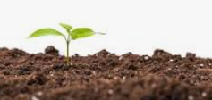
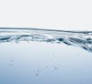

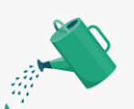


Home Learning Challenge Ideas
Can you plant a seed? Can you describe what happens to it?
What plants are in your garden?
Can you take a photo of plants you see on a walk to the park?
What can you cook with your adult using vegetables?
What fruits and vegetables do you like to eat?
Can you create some fruit or vegetable art work? You might print with paint, draw some you have at home or create a photo collage.
Can you find a minibeast outside?
We would love to see any of your own topic work that you choose to do at home. You might do something completely different to these ideas.
Please share your home learning with us on Tapestry!

Useful Weblinks
Oliver's Vegetables story
Cbeebies - Down on the Farm
Supertato story
Where does food come from?

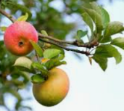
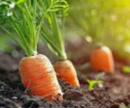
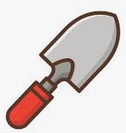

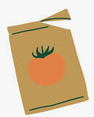
Apples grow on trees.
Carrots grow underground.

