Home Learning Mats- Journeys

a

Journeys – Vehicles |  | Transportation – How will we get there?
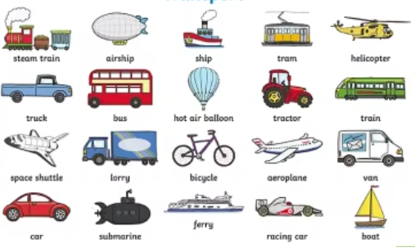

Key texts

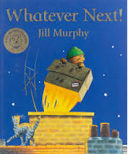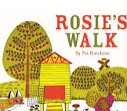
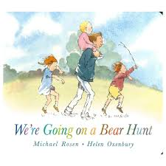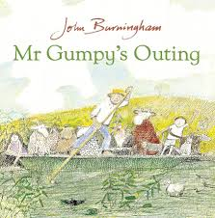

Have you been on a journey before?
Where did you go?
How did you get there?
Where in the world would you like to go and how would you get there?
What would you use to plan your journey?
What journeys can you make on foot?
What kinds of transport might we find on the road?

Home Learning ideas

- Talk about journeys you take together (to the shop, nursery, park).
- Go on a short walk and notice what you pass on the way.
- Draw or talk about what you saw on your journey.
- Play with toy cars, buses, trains or planes.
- Build bridges or tunnels with blocks or boxes.

Definitions

Travel | To go from one place to another.
Journey | A long trip from one place to another.
Adventure | A journey or activity that is exciting or dangerous.
Vehicle | Something used to carry and move people or things. Cars, buses and aeroplanes are vehicles.
Transport | Something that carries or moves something.
Map | A picture of a particular area of the world

Useful Links
https://www.bbc.co.uk/teach/school-radio/articles/zfwjcqt - Vehicles.
https://www.youtube.com/watch?v=0gyI6ykDwds – We’re Going on a Bear Hunt.
https://www.youtube.com/watch?v=Mi_DV_DWN8M – Mr Gumpy’s Outing.
https://www.youtube.com/watch?v=6c5cb0u0rPM – Whatever Next.

