EYFS Knowledge Mat- Traditional Tales

a

Key Characters

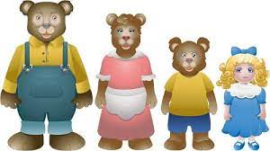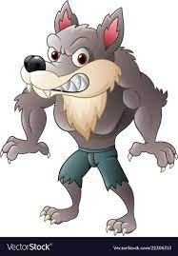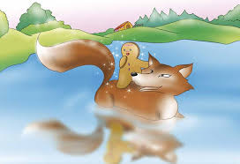

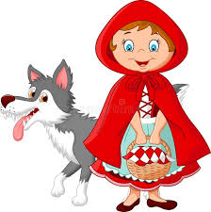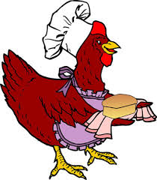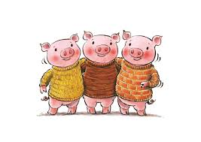

Key texts

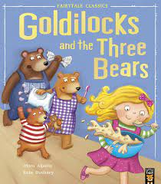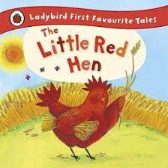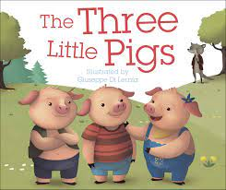
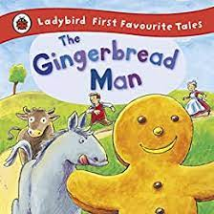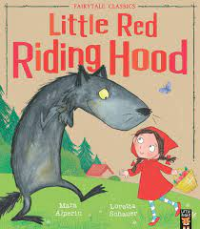

Home Learning

- Act out the story together
- Bake some bread
- Gingerbread playdough
- Make your own story map
- Try making some porridge
- Build the bears’ houses using blocks or boxes
Useful links

https://www.youtube.com/watch?v=JdvJZD-cplg

https://www.bbc.co.uk/cbeebies/stories/storytime-goldilocks-and-the-three-bears

https://www.bbc.co.uk/cbeebies/watch/musical-story-of-the-gingerbread-man-trailer

