Facts to learn:
People live in lots of different types of homes. What type of home do you live in?

flat semi-detached house detached house bungalow caravan
We have five senses. We use them to see, hear, taste, touch and smell.

Different parts of our body:

foot hand head ear leg eyes arm nose

Autumn term 1-
All About Me 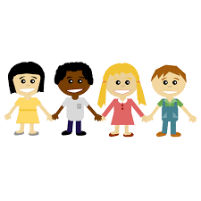
Topic Vocabulary
Portrait: a painting or drawing of a person
Home: the place where we live
Family: a group of people who we live with or who we spend time with that are related to us.
Pet: an animal that we look after and that lives in our home.
Body: the physical parts of ourselves including skeleton.
Senses: taste, smell, touch, sound and sight
Emotions: feelings such as happy, sad, angry, worried and excited
Difference: how people or things are the same or different
Useful Weblinks
Topsy and Tim's first day at school
Cbeebies Celebrating Differences
Part of the body labelling game
Different types of homes

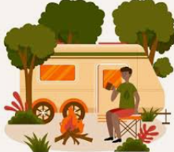
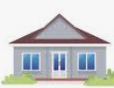
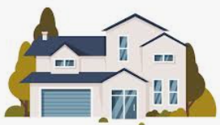
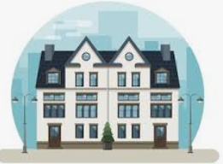


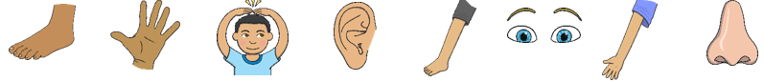
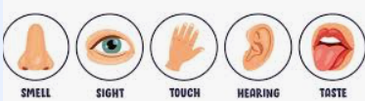
Home Learning Challenge Ideas
- Can you draw a picture of you and people who are special to you?
- Please share your photos if you have any pets on Tapestry.
- Sing Heads, Shoulders, Knees and Toes.
- Try a new food… did you like it?
- Ask a grown up to help you make a healthy fruit salad.
- Share a photo of when you were a baby.
- Use paint to make handprints of people in your family, cut them out and order them smallest to largest.
We would love to see any of your own topic work that you choose to do at home. You might do something completely different to these ideas.
Please share your home learning with us on Tapestry!

