rnrney
Topic Vocabulary
Celebrate - To make something special with things like gifts, parties or activities.
Festival - A ceremony or celebration that repeats, often once a year.
Party - People coming to gather to celebrate and have fun
Decoration - To make something more beautiful by adding to it.
Birthday - The day and month that someone was born on.
Fireworks: Bright lights and colours that go boom in the sky!

Autumn 2:
Celebrations

Facts to learn:
Here are questions that we will be exploring to help us learn about different celebrations all around the world:
Why do we celebrate?
Who do we celebrate with?
What do we do to celebrate?
What celebrations do you take part in throughout the year?
What celebrations are special to you and your family?

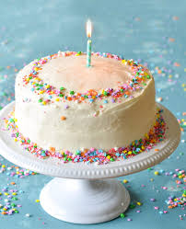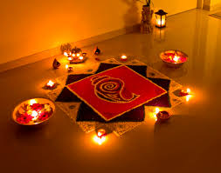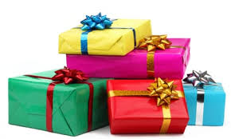

Useful Weblinks
https://www.bbc.co.uk/cbeebies/watch/lets-celebrate-eid
https://www.bbc.co.uk/cbeebies/watch/lets-celebrate-christmas
Why Do You Like Celebrating?

Home Learning Challenge Ideas
- Celebration Role Play – set up a pretend party area using soft toys or family members.
- Make a Celebration card - Talk about who the card is for and why they’re special.
- Family Celebration Photos - Look at photos of family birthdays, weddings, or festivals. “Who is in this picture?” “What were we doing?” “How did you feel?”
- Make some decorations! Can you make some bunting?
- Make some simple celebration treats – cupcakes, fruit kebabs or biscuits.
- Can you create your own firework painting for Bonfire Night?
We would love to see any of your own topic work that you choose to do at home so you might do something completely different.
Please share your home learning with us on Tapestry!

