Nursery Newsletter – Monday 22nd June

I have been busy over the last couple of weeks getting nursery ready for partial reopening. Here are a couple of pictures of nursery ready for our rainbow bubble next week.
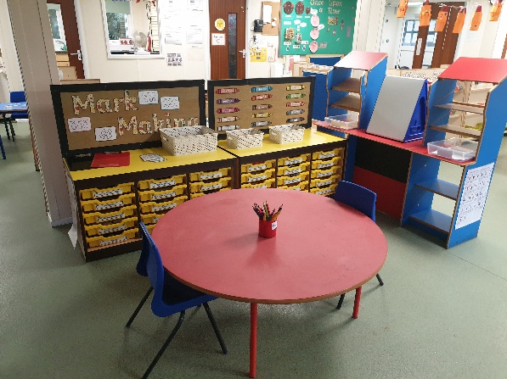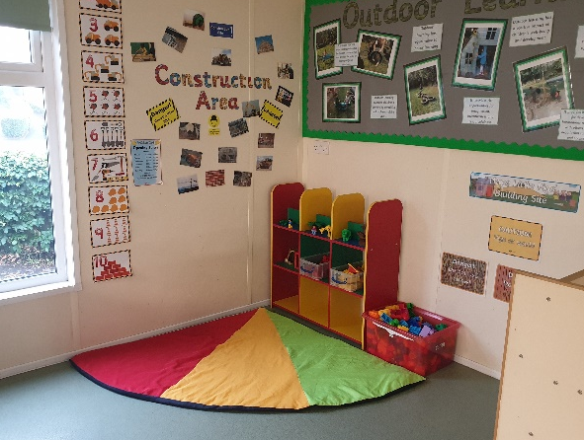
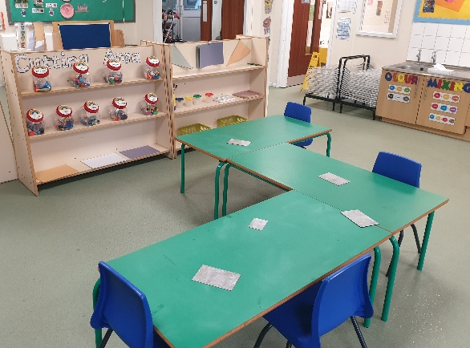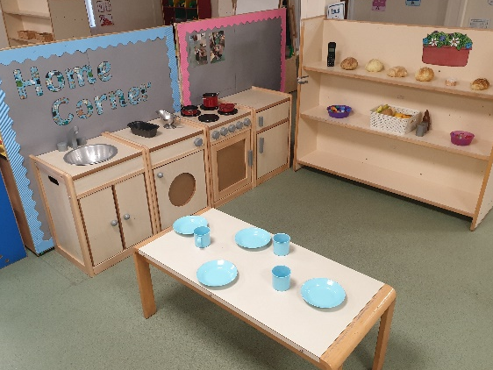
We still have lots of choice and different areas of provision and can’t wait to welcome some of you back!
Whether you are continuing with home learning or joining the sunshine or rainbow bubble I just want to thank you for all your support and cooperation over this whole period. It has been so lovely to speak to you on the phone and I just want to reassure you that no matter your choice of home learning or return I am here to support you and your child. So please do get it touch via tapestry, phone or learning@beechwoodprimaryschool.co.uk if you do have any questions.
Topic – Plants and Animals
Here is a reminder of last week’s topic challenge:
Topic Challenge: Pets
Last week’s challenge was all about PETS! What is a pet? - It's a type of animal that usually lives with people in a house. I have three cats. George, Molly and Tilly. Here they are. Do you have a pet?
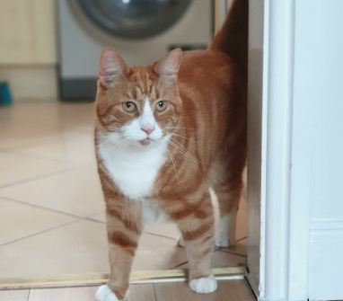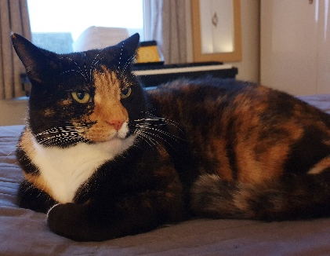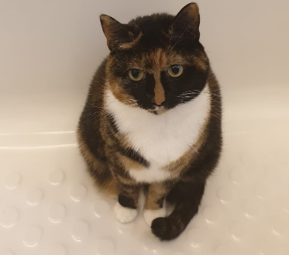
Have a look at some of the different types of pets that people have such as cats and dogs. Cbeebies also have some great links and videos all about pets - https://www.bbc.co.uk/cbeebies/topics/pets?page=2
Challenge: Have a think and a talk about how we look after our pets. It might be easier to pick one type of pet and think about what they would need and what we need to do to make sure they are loved for and cared for correctly. e.g. -Food and food bowl -Water and water bowl -Collar, lead, brush - Toys - to keep them entertained. Is there anything else that they will need? Where would you get all of this from? Why not look at a pet shop website for ideas and to help with the discussion and exploration. https://www.petsathome.com/
Challenge 2: Using whatever resources you can find at home e.g. bowls, hairbrush, animal teddies, can you make a pet or vet role play area so you can look after your own pet?
Have fun and don't forget to share what you get up to!
This week we are going to be looking at bees and learning some interesting facts about why we need bees.
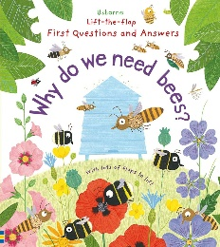
Maths
Please remember to do daily active counting!
Here is the reminder of the Maths challenge that I posted on tapestry:
Maths Challenge: Comparing quantities – more, same and fewer
Last week’s maths challenge was all about comparing quantities using the language of more, same, less and fewer.
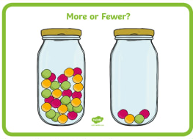
Challenge: Watch this song of a dog and a cat having a lovely picnic. Who has more buns? https://www.bbc.co.uk/cbeebies/watch/numberblocks-who-has-more-song
Have a go at comparing objects using any objects around the house. Why not use some building bricks to build a tower? Which tower has more bricks? Which tower has fewer brick? What if they are the same?
Explore the use of the words 'more' and 'fewer' in a range of ways, using different quantities and objects.

Have you been doing daily counting? Can you count up to 20? Can you count backwards from 10 – 0? This week we will be doing lots of counting up to 20.


Literacy
Story time – Please set aside some time each day to share a book and sing nursery rhymes together.
Here is a reminder of the Literacy challenge that I posted on Tapestry last week:
Literacy Challenge:
Last week’s literacy focus was story time with me – I read books that had an animal/pet focus like ‘Dear Zoo’. Why don’t you listen to the story on YouTube https://www.youtube.com/watch?v=rudDGRQ9QGA
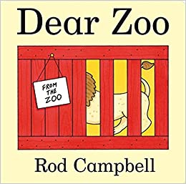
Can you find any more books with pets or animals in? What is your favourite animal story?

This week we will be focusing on rhythm. In nursery we do lots of rhythm work by clapping and using different instruments and rhythm sticks (claves). We look at how many syllables are in words such as straw-berr-y and clap or bang the sticks for each syllable.
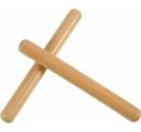

Physical Development
Here is a reminder of the topic challenge that I posted on Tapestry last week:
Physical Development Challenge:
Last week’s physical development challenge was to see if we could move like pets!
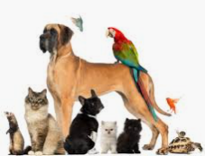
Think about how we move? How do we walk? We often move around using two legs, we might like to hop on one leg or even crawl but normally we walk on two feet!
Now think about animals and pets. Cats, dogs, bunny rabbits. How do they move? Animals move in lots of different ways.
Challenge: Can you travel/move around the house like lots of different animals? Can you move around on all four like a cat? Can you hop like a bunny rabbit? Can you slither like a snake? Can you flap your wings like a bird? Think about which part of your body you need to use. Do you move fast or slow? Have fun moving in different ways and let me know which is your favourite way to move.

This week’s physical development challenge will be all about making our own obstacle course and thinking about moving in lots of different ways.
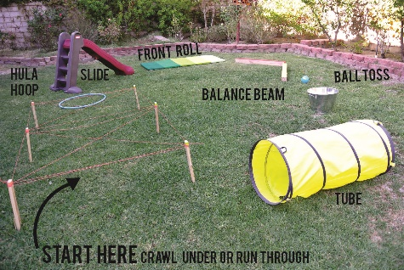
Tapestry learning webs
The week 13 Tapestry learning web has now been released! Check it out for some great ideas!

Please get in touch through the email learning@beechwoodprimaryschool.co.uk if you need any support with tapestry or for any other learning related query.
Please look after yourself and keep in touch.
Mrs Isenring

