Nursery Newsletter – Monday 15th June
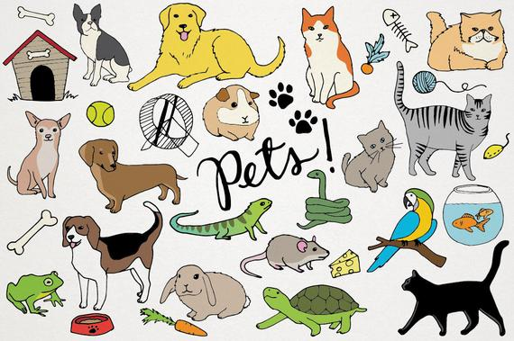
Topic – Plants and Animals
Here is a reminder of the topic challenge that I posted on Tapestry last week:
Topic Challenge

Last week’s topic challenge was a vote to see what type of animals we were most interested in learning about next. You were asked to talk about different groups of animals and vote out of:
- Minibeasts
- Farm animals
- Pets
- Zoo/jungle animal
- Any other animal types
Thank you to everyone that voted. The winner was PETS.
This week we are going to be looking at Pets. Have you got any pets? If you were to get a pet what pet would you get? What do you need to do to look after a pet? Research a little bit about an animal that people often have as a pet.

Maths
Please remember to do daily active counting!
Here is the reminder of the Maths challenge that I posted on tapestry:
Maths Challenge: Patterns in Animals – Butterfly Symmetry
Last week’s maths challenge was all about looking at the patterns in nature – particularly in butterflies.
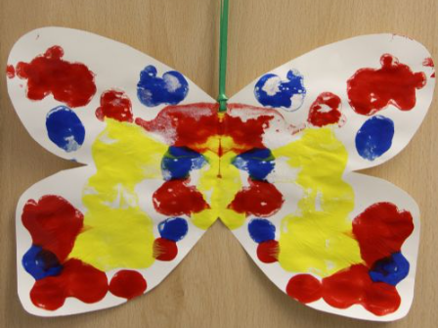
During the life cycle of a caterpillar, the caterpillar spins a cocoon and then comes out as a butterfly. Butterflies are so beautiful and they all look so different with different colours and patterns on their wings. Their patterns and colours are symmetrical which means whatever is on one wing is exactly the same on the other.
Challenge: Have a look at different butterflies and have a look at their wings and the patterns on them.
Can you cut out a shape of a butterfly and then fold it in half? Paint different colours and patterns on one wing. Before it dries fold the other half on top of the painted wing and press down hard. Open up the butterfly and hopefully you will have a beautiful symmetrical butterfly.
Can you think of other animals that have patterns on their skin? What about a spotty pattern? Stripy pattern?
This week we will looking at number again. We will be comparing quantities and using words like more, same, and less/fewer.
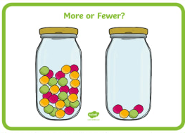
Literacy
Story time – Please set aside some time each day to share a book and sing nursery rhymes together.
Here is a reminder of the Literacy challenge that I posted on Tapestry last week:
Literacy Challenge:
Last week’s literacy challenge was once again all about letters and posting!

Challenge: Why not post a letter/picture to me at Beechwood Primary and I can put it on display in Nursery? Or you could make a picture or letter for a family member or friend that you could send to them in the post, or you could be the postman/postwoman and post it yourself through their letterbox!! What are you going to send to them? What about a fantastic rainbow? Or a minibeast or a growing picture? It can be anything you like!
Talk about the things you need on a letter. What is a stamp? Where does it go on the letter? What is an address? Where do we write this? What is your address? Do you know what number house you live at? Have you had any post delivered this week that you could look at together?
This week we will be looking at the story Dear Zoo as it links in really nicely with our topic.
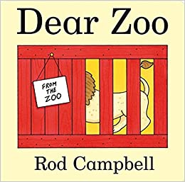

Physical Development
Here is a reminder of the topic challenge that I posted on Tapestry last week:
Physical Development Challenge:
Last week’s physical development challenge was all about using objects to aim at a target.
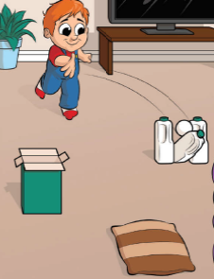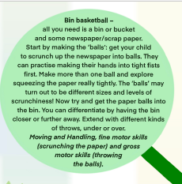
Challenge: Can you scrunch up some paper to make your own 'balls' to throw? Can you throw them into a bin/box? Or you could use different balls/items of different weight/size to really develop the skill of throwing and aiming.
You could make different targets to aim at. You could use some old cartons to make a game of skittles to knock down!

This week’s physical development challenge will be a moving in different ways challenge. Think about how different animals/pets move. Can you move around on all four like a cat? Can you hop like a bunny rabbit? Can you slither like a snake? Can you flap your wings like a bird?
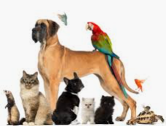
Tapestry learning webs
The week 12 Tapestry learning web has now been released! Check them out for some great ideas!
Sharing fun!
Also, feel free to share anything that you are getting up to or anything you would like to share, even if it is not related to this week’s challenges as I am still eager to see what fun things you are getting up to!
This week I wanted to share some pictures. One is a picture of some amazing biscuits that my best friend sent to me to make me smile . The other two are pictures of fresh pasta, as my husband Josh had decided he wanted to have a go at making pasta from scratch. It’s definitely a first in our household and he said it was surprisingly easy to make with just flour and eggs! It was yummy!
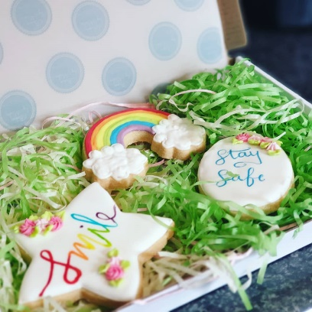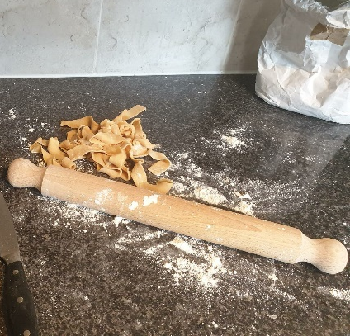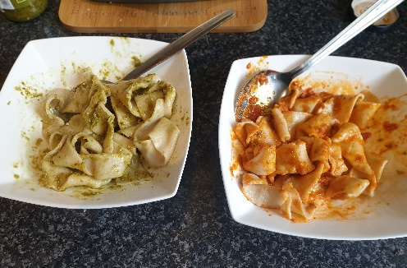

Please get in touch through the email learning@beechwoodprimaryschool.co.uk if you need any support with tapestry or for any other learning related query.
Please look after yourself and keep in touch.
Mrs Isenring

