Nursery Newsletter – Monday 8th June
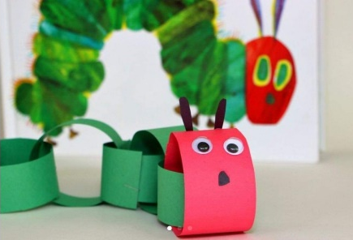
Topic – Plants and Animals
This half term we will be moving on from plants and focusing more on animals. I thought we would kick start this exploration by looking at a minibeast that we find a lot in our gardens – caterpillars. Here is a reminder of the topic challenge that I posted on Tapestry last week:
Topic Challenge
Last week’s topic challenge was all about caterpillars and butterflies. Mrs Lyons (A reception teacher) made a video of a caterpillar poem (see tapestry). Can you join in with her and recite the poem? She also sent me a picture of her little boy who found a real caterpillar in the garden. Can you find one in your garden?
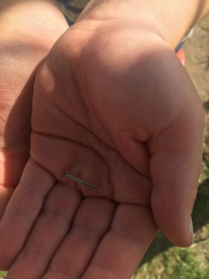
Also, why don't you remind yourself of the story of 'The Hungry Caterpillar'. Please click on the link to look closely at a real caterpillar https://youtu.be/vm4EgwOjzNY
Challenge: Can you have a go at creating your own caterpillar or butterfly. This can be in any form. You could use chalk, paint, toilet rolls, paper, fruit.
This week we are going to be having a vote on Tapestry about what group of animal you would like to learn about next week! Some options would be: minibeasts, farm animals, pets, zoo/jungle animals! Have a talk about what you would prefer!
Maths
Please remember to do daily active counting!
Here is the reminder of the Maths challenge that I posted on tapestry:
Maths Challenge: Shape Hunt
Last week’s maths challenge was all about looking at 2D shapes. 2D shapes are flat shapes. Why don't you listen to this song that is all about 2D shapes, it names them and talks about some of the features such as how many sides they have. https://m.youtube.com/watch?v=IkZs2_1-YJU
Also, watch this number block episode all about flat 2D shapes https://www.bbc.co.uk/iplayer/episode/b0bp2qlb/numberblocks-series-3-flatland
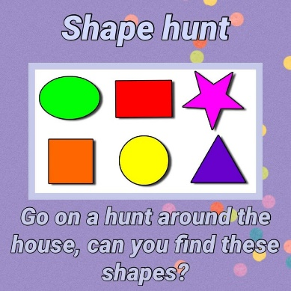
Challenge: Can you go on a shape hunt and see if you can spot any 2D shapes in your house or around your local area? As you find them see if you can remember the name of the different shapes.
Happy shape hunting!
This week we will be looking at pattern and patterns we find on animals. We will be looking at the patterns on butterfly’s wings and introducing the word symmetry.
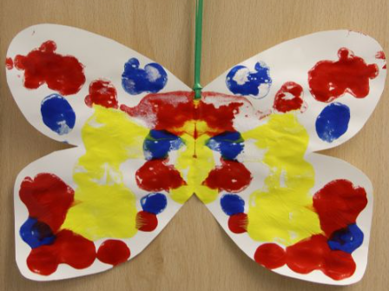
Literacy
Story time – Please set aside some time each day to share a book and sing nursery rhymes together. Why don’t you send a picture/video into Tapestry of you enjoying story/rhyme time!
Here is a reminder of the Literacy challenge that I posted on Tapestry last week:
Literacy Challenge:
Last week’s literacy challenge was all about letters and posting! (This challenge will be over two weeks).
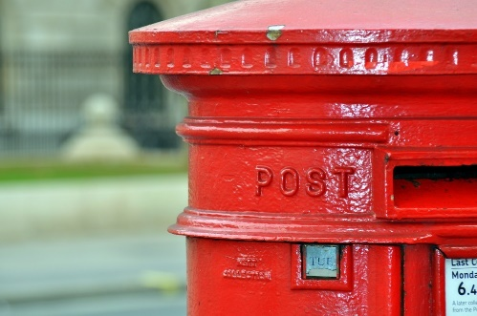
Challenge: This activity is all about motivation to practise early writing skills. Whether your child is making marks or beginning to form letters/draw pictures, having reasons to write keeps them wanting to do more.
If you can, have a look at a post box. This could be a picture, or if there is one near your home you could go for a walk together and investigate it. Talk together about what a post-box is for. How do the letters get in? How do they get out? Who collects them? Then what happens to the letters – how do they get to the people they are for?
Explain that you are going to make your very own post box. Look for a suitable box together – use lots of language: too big, too small, just right. What does the post box need? A hole for the letters to go in, an opening at the back to get them out, maybe some colour. Is there any writing on a post-box?
Now it’s time to write some letters! Or draw some pictures to post! Use small bits of paper and a felt tip/pencil. Who would your child like to write to? What will they write about? What would they like to draw? Chat as your child makes marks. Can they give meaning to their marks? Model writing your own letter at the same time.
If you have some envelopes, you can use these to put the letters in. Or you can make them by folding some paper over each letter. Go back to your chat about post-boxes and how the letters get to where they need to go? How does the post-person know who they are for and where they live? Model writing an address on the front of the envelope/paper.
Can you and your child make some stamps for the letters? Maybe you have some stamps they can look at first or find a picture of one. Use tiny bits of paper and a glue stick. Post it!
This week we will be continuing to focus on letters and posting. Why not post a letter/picture to me at Beechwood Primary and I can put it on display in Nursery? What about a fantastic rainbow? Or a minibeast or a growing picture? It can be anything you like! Or why not post a letter to a family member or a friend?
Mrs Isenring
Beechwood Primary School
Kentmere Avenue
Leeds
LS14 6QB
Physical Development
Here is a reminder of the topic challenge that I posted on Tapestry last week:
Physical Development Challenge:
Last week’s physical development challenge was a one-minute physical challenge.
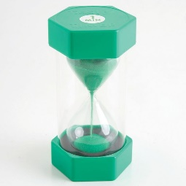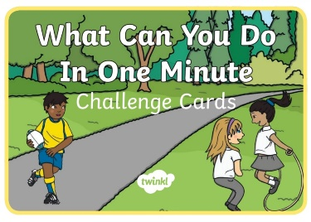
Challenge: Use a timer and set it to 1 minute. Sit quietly and wait for the 1 minute to pass. Did it feel like a long time? See how many tumps you can do in 1 minute? What about start jumps? Hops? Rolls? Touch your toes? Catching of a ball? Find lots of fun active things to do in 1 minute!
This week’s physical development challenge will be a target challenge. We will be exploring the skill of aiming and throwing.
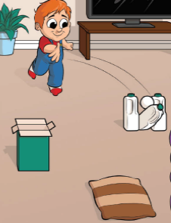
Tapestry learning webs
Here are the next two learning webs (week 10 and week 11). Check them out for some great ideas.
Sharing fun!
Also, feel free to share anything that you are getting up to, even if it is not related to this week’s challenges as I am still eager to see what fun things you are getting up to! Here is something fun that I got up to this weekend.
I went strawberry picking! What did you get up to?
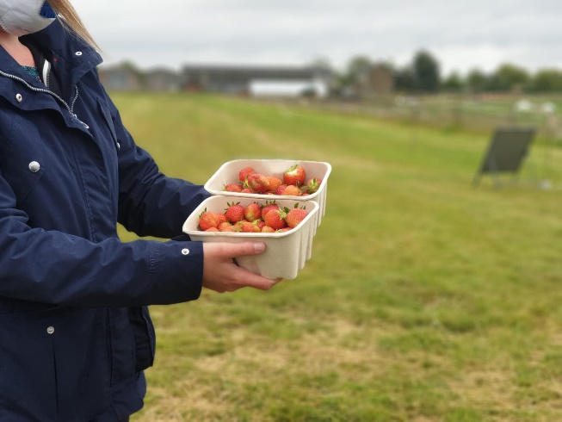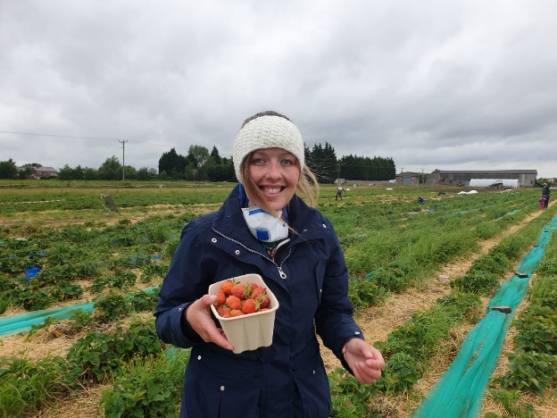
Please get in touch through the email learning@beechwoodprimaryschool.co.uk if you need any support with tapestry or for any other learning related query.
Please look after yourself and keep in touch.
Mrs Isenring

