Nursery Newsletter – Monday 25th May
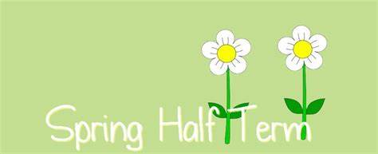
Hello Everyone,
We have come to the end of the first full half term of school closures. It has definitely been a challenging and unusual time and I just wanted to thank you all for your continued support during this difficult time and your continued engagement. Whether it be uploading to Tapestry with something you have been up to, or in response to one of the challenges or whether you have been in to school to pick up a pack or engaged over the telephone. It has really helped to continue to foster a Nursery community, even if we are all in our own homes.
Over the Spring Half Term, I will not be uploading my usual challenges and instead encourage you to maybe have a go at any you missed or just continue to have lots of fun in play. Please still upload what you get up to and I will share what I am up to during the holidays. I will be going on lots of walks, reading and looking after my plants that I have grown.
I will also be having a look at some of these great websites for ideas of what we can do next half term for our topic. Take a look and let me know if you have any ideas of anything you would like to explore next.
- Woodland Trust Blog https://www.woodlandtrust.org.uk/blog/
- Wildlife Trust - https://www.wildlifetrusts.org/looking-after-yourself-and-nature
-RSPB - https://www.rspb.org.uk/fun-and-learning/
Topic – Plants and Animals
Here is a reminder of the topic challenge that I posted on Tapestry last week:
Topic Challenge
Last week’s topic challenge focused on nature exploration and using this exploration for a range of crafts and activities.
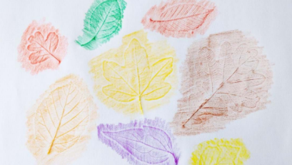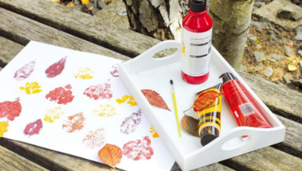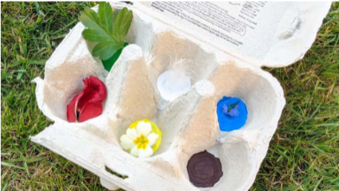
Challenge 1: Colour bingo
Paint/draw some colourful splodges on a piece of card or inside the sections of an egg box, then see if you can find natural items to match! The winner is the first to find them all.
Challenge 2: Go on a leaf hunt
At this time of the year the leaves are so vibrant and green! Leaves are also a really useful way of teaching children how to identify different trees. So use the leaf spinning ID tool and use it to identify trees in your local area? It’s a fun activity to do on your daily exercise, too.
Challenge 3: Get crafty with the nature
Make a nature bracelet - Stick some double-sided tape or glue to a strip of card and fasten it around your wrist. Then head out into your garden/local area and look for petals, leaves or other items that catch your eye. Simply stick them to the card to make a beautiful bracelet!
Leaf printing/rubbing - Leaves have such interesting shapes and textures. Paint one side of each leaf and press them onto a sheet of card. Gently peel the leaves away to reveal intricate prints! Or alternatively, put a leaf behind a piece of paper and rub a crayon over it sideways to create a fantastic print.
Maths
Please remember to do daily active counting!
Here is the reminder of the Maths challenge that I posted on tapestry:
Maths Challenge:
Last week’s maths challenge was all about the number 5. To get a really good understanding of number, you need to have a very good image of each number. You need to understand the 'fiveness' of five and understand that 5 represents the quantity of 5 things. You need this understanding to be able to order numbers, with one more each time and identify if there are any errors in the pattern.
Challenge 1: Ordering numbers 1-5
Watch the numberblocks episode called 'of we go' as this focuses on ordering and looking carefully for any missing numbers https://www.bbc.co.uk/iplayer/episode/b08cr0y7/numberblocks-series-1-off-we-go
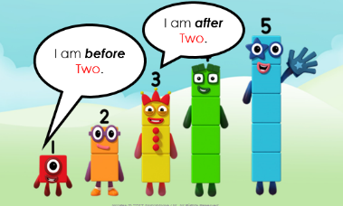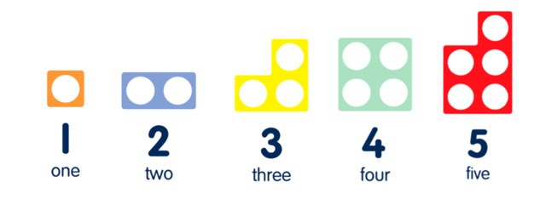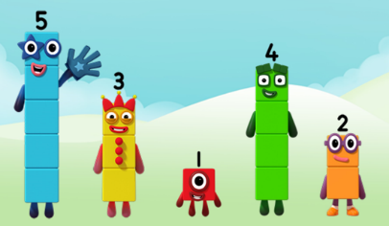
I posted a video of me showing the numicon 1-5 and ordering it. Have a look at the numicon in this image and look at how it has been ordered from 1-5. Could you have a go at finding something that you could use to have a go at ordering 1-5, lego or blocks are great as you can make different quantities or you could make flash cards by drawing simple images like hearts/apples.
Challenge 2: Looking at how 5 can be broken up into two parts using language of addition and subtraction. The numberblocks episodes called 'Holes' and 'Hide and seek' are great at exploring this concept. https://www.bbc.co.uk/iplayer/episode/b08dmjsk/numberblocks-series-1-holes https://www.bbc.co.uk/iplayer/episode/b08dmn88/numberblocks-series-1-hide-and-seek
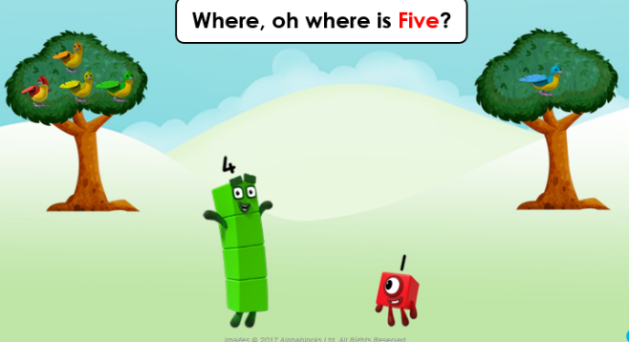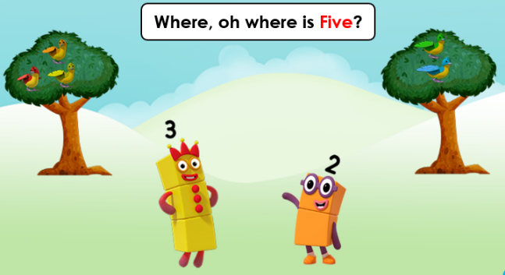
Can you use objects in your house to explore how 5 can be broken up into two numbers? Use the words add and subtract/takeaway in a playful way as you explore.

Literacy
Story time – Please set aside some time each day to share a book and sing nursery rhymes together. Why don’t you try and learn a new nursery rhyme such as ‘There’s a Worm at the Bottom of the Garden.’ – Singing hands is great and can be found on Youtube. Here is a link
https://www.youtube.com/watch?v=xQ2dvnu6uJs&list=OLAK5uy_kNGqGb6_WAKLo-Koua9q1qKqpr2E44XZU&index=22
Here is a reminder of the Literacy challenge that I posted on Tapestry last week:
Literacy Challenge:
Last week’s literacy challenge was all about rhyme again. Lots of rhymes have a focus on number 5, so this links in nicely with our number work.
What rhymes/songs can you think of with the focus of 5? 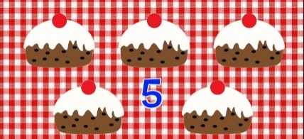 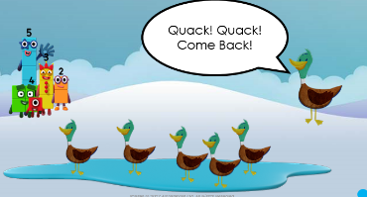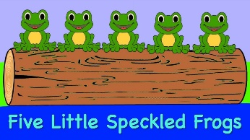
Here are just a couple of my favourite ones but there are lots more: - 5 little speckled frogs - 5 little ducks - 5 little monkeys - 5 currant buns https://www.bbc.co.uk/teach/school-radio/nursery-rhymes-five-currant-buns/zm4nmfr
Challenge: Please enjoy singing a familiar rhyme with 5 and then have a go at learning one that is unfamiliar. Which one did you learn? You could even add your own words and make your own rhyme of 5 up using something you love like cars.
Use props to sing the song. You could use pebbles to represent the 5 ducks or frogs and take them away as you are singing.

Physical Development
Here is a reminder of the topic challenge that I posted on Tapestry last week:
Physical Development Challenge:
Last week’s physical development challenge was all about practising our skill of balancing.
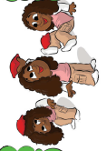
Challenge: Using a toy or beanbag can you keep it balanced on your body? Can you keep it on your head? knee? hand? Try your best to keep it still. How long can you keep it balanced for?
Make it more challenging to see if you can move around while keeping it balanced on your body part or while balancing on one leg.

Please get in touch through the email learning@beechwoodprimaryschool.co.uk if you need any support with tapestry or for any other learning related query.

Please look after yourself and keep in touch.
Mrs Isenring

