Nursery Newsletter – Monday 18th May

Topic – Plants and Animals
Here is a reminder of the topic challenge that I posted on Tapestry last week:
Topic Challenge
Last week’s topic challenge continued the focus of growing, looking particularly at fruit. I read the story ‘Oliver’s Fruit Salad’ and made my own fruit salad.
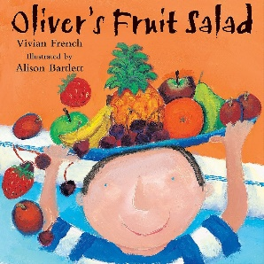
Challenge: To have a talk about fruit. What is your favourite fruit? How do you like to eat it? Talk about how fruit are healthy and look at how different fruit grows. Have a look at how pineapples grow in Costa Rica
https://m.youtube.com/watch?v=UVL8NXigTkI
Can you make a fruit salad like Oliver did in the story? What will you put in your fruit salad? I had raspberries, blueberries, orange and banana in my fruit salad. I also had it with yoghurt and meringue.
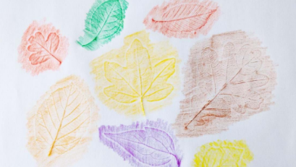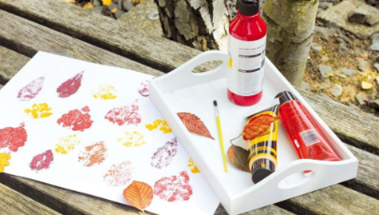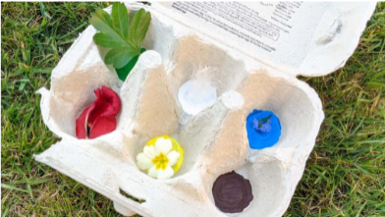
This week we are going to continue our focus on plants and look at some nature crafts such as nature colour bingo and a leaf hunt to make leaf printing/rubbings and nature bracelets.
Maths
Please remember to do daily active counting!
Here is the reminder of the Maths challenge that I posted on tapestry:
Maths Challenge:
Last week’s maths challenge was all about the number 5. Can you count to 5? Can you show me 5 with your hand? It's a high five! 1, 2, 3, 4, 5. Can you do 5 claps? 5 Jumps? 5 Stamps?
Start off by watching the number 5 Numberblocks. Here is a link on CBeebies: https://www.bbc.co.uk/iplayer/episode/b08d630h/numberblocks-series-1-five
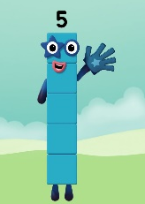
Challenge 1: Can you go on a five hunt around the house. What can you find 5 of?
Challenge 2: Can you sing the song '5 little ducks went swimming one day'. Talk about how it is one less each time. https://www.youtube.com/watch?v=kbLeGXQe-fM There are lots of songs that contain 5. Can you think of anymore?
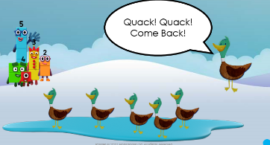
High five!
This week we will be continue to develop our understanding of number 5. I will introduce/recap some mathematical equipment such as numicon and ten frames to represent the numbers 1-5.
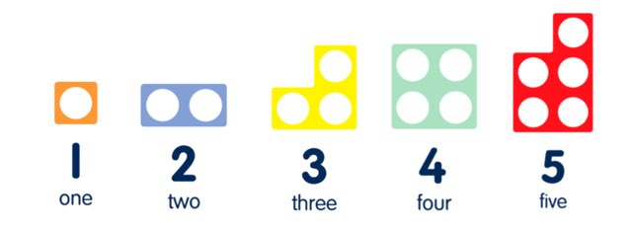
Literacy
Story time – Please set aside some time each day to share a book and sing nursery rhymes together. Why don’t you try and learn a new nursery rhyme such as ‘There’s a Worm at the Bottom of the Garden.’ – Singing hands is great and can be found on Youtube. Here is a link
https://www.youtube.com/watch?v=xQ2dvnu6uJs&list=OLAK5uy_kNGqGb6_WAKLo-Koua9q1qKqpr2E44XZU&index=22
Here is a reminder of the Literacy challenge that I posted on Tapestry last week:
Literacy Challenge:
Last week’s literacy challenge was all about Fred talking.
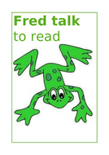
Have a look at the beginning of this clip to get familiar with Fred talking (this is sounding out). https://www.youtube.com/watch?v=dEzfpod5w_Q
To be able to Fred talk adults need to say the sounds very clearly. Here is a handy guide of how to say the sounds. Take a look at the Parent Video - How to say the sounds here: https://www.youtube.com/watch?v=TkXcabDUg7Q.
Note at this point your child does not need the visual of the written letter but are just tuning into the sounds orally. So for instance if you break the word d-o-g into three sounds can your child here that it says dog.
Fred talking challenge:
Use a teddy or a puppet and call it Fred. Did you make a sock puppet? This would be a great Fred. Fred talks in sounds. So instead of Fred saying cat. He says c-a-t. Speaking like Fred helps children to understand that words are made up of sounds. Use Fred Talk throughout the day to help children practise blending sounds together. Watch my video of Fred doing some Fred talking.
Here are some great Fred talking games.
Fred says…
1. Say: Fred says put your hands on your h-e-d. Ask children to repeat. Pause to allow children to jump in with the whole word and do the action.
2. Say: h-e-d, hed. Ask children to repeat.
Repeat with: b-a-k, t-u-m, l-e-g, h-a-n-d, f-u-t, n-ee, r-u-n, s-k-i-p, h-o-p, s-t-o-p
Fred I spy
1. Say: Fred says ‘I spy something r-e-d’ Ask children to repeat. Pause to allow children to ‘jump-in’ with the whole word and point to something red.
2. Say: r-e-d, red. Ask children to repeat.
Repeat with: b-l-oo, g-r-ee-n, b-l-a-k, b-r-ow-n
Fred’s fridge
Milk m-i-l-k, juice -j-oo-s; cream c-r-ee-m; eggs e-g-s; corn c-or-n; grape g-r-ay-p; pear p-air; peas p-ee-z; leek l-ee-k
Fred’s wardrobe
Scarf s-c-ar-f; hat h-a-t; coat c-ow-t; socks s-o-c-s; shorts sh-or-t-s; dress d-r-e-ss; skirt s-k-ir-t
Use Fred Talk for single syllabic words at the end of sentences throughout the day.
E.g. It is time for l-u-n-ch...lunch, come and sit on the f-l-oor...floor.
Happy Fred Talking.
This week we will be focusing on rhymes – especially rhymes that have a focus of 5 to fit in with our Maths work on number 5.
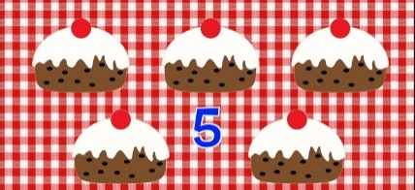
Physical Development
Here is a reminder of the topic challenge that I posted on Tapestry last week:
Physical Development Challenge:
Last week’s physical development challenge was a funky fingers craft activity!
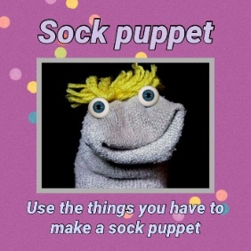
Challenge: Can you make a sock puppet using an old sock and things you might have around the house.
Once you have made it, use your hand to make it talk. Can you role play with your puppet? You could also use your sock puppet to do some sound (Fred) talking to complete the Literacy challenge.
This week’s physical development challenge will be a balancing challenge. We will be exploring the skill of balancing by seeing if we can balance a soft toy or beanbag on different parts of our body.
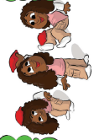

Please get in touch through the email learning@beechwoodprimaryschool.co.uk if you need any support with tapestry or for any other learning related query.

Please look after yourself and keep in touch.
Mrs Isenring

