Nursery Newsletter – Monday 11th May
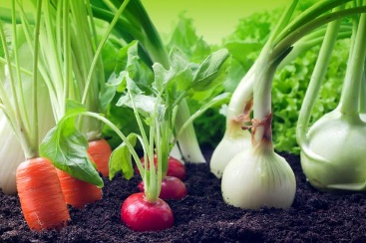
Topic – Plants and Animals
Here is a reminder of the topic challenge that I posted on Tapestry last week:
Topic Challenge
Last week’s topic challenge continued the focus of growing, looking particularly at vegetables. I read the story ‘Oliver’s Vegetables’ and made my own vegetable soup.
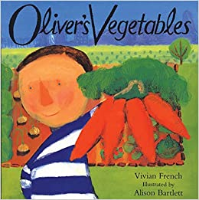
Challenge: To have a talk about vegetables. What is your favourite vegetable? How do you like to eat it? Talk about how vegetables are healthy and look at how vegetables grow. Here is a link of how a potato grows. https://youtu.be/lYBuY-DnCJc
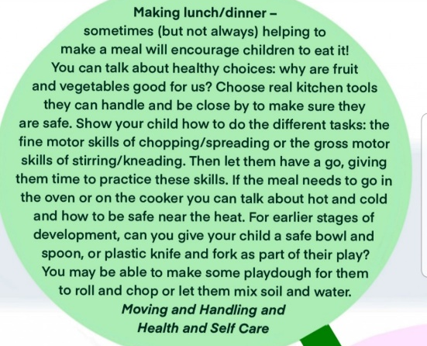
Making lunch activity – Can you have a go at making something with vegetables?
This week we are going to continue to look at growing and we will have a look at the next book in the series: ‘Oliver’s Fruit Salad.’
Maths
Please remember to do daily active counting!
Here is the reminder of the Maths challenge that I posted on tapestry:
Maths Challenge:
Last week’s maths challenge was based on the book ‘The Very Hungry Caterpillar’. It is a great book full of Maths and it fits in really well with our topic. Have a look at the story together. Here is a link to an animated version: https://www.youtube.com/watch?v=75NQK-Sm1YY
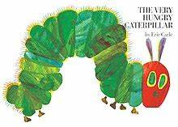
Maths Challenge:
Days of the week - Learning time and the days of the week is a really tricky concept and this book is a great way to talk about and learn the days of the week. Look at the book and talk about what day it is today? What day was it yesterday? What day is it tomorrow? Here are some songs for listening to the days of the week. https://www.youtube.com/watch?v=7AvNq2CQnOI https://www.youtube.com/watch?v=HtQcnZ2JWsY
Counting fruit - On each day The Very Hungry Caterpillar eats its way through lots of fruit and food. Each day it eats more and more. Encourage the children to count the food. Can you find fruit and food around the house that you could count?
Caterpillar - Look at the caterpillar. Can you count the different sections of his body? Can you now make your own caterpillar by finger painting or drawing? How many body parts has he got? Is he a long or a short caterpillar? Can you make lots of caterpillars of different lengths?
This week we will be focusing all about the number 5. We will focus on number 5 for the next couple of weeks.
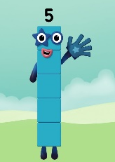
Literacy
Story time – Please set aside some time each day to share a book and sing nursery rhymes together. Don’t worry if you’re reading the same book again or always singing the same rhyme as repetition is key at this age.
Here is a reminder of the Literacy challenge that I posted on Tapestry last week:
Literacy Challenge:
Last week’s literacy challenge was the create a reading den or a comfy place to enjoy reading. It is so important that children read for pleasure and see it as an enjoyable experience. Have fun creating a comfy place to read a favourite story together. What is your favourite story?
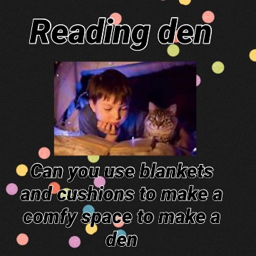
Did you make a reading den? I would love to see some pictures.
This week we will be looking at and exploring oral blending – this is where children listen to the different sounds in the words and put them back together (blend) to make the word. We use Ruth Miskins Phonics (RML) at school and call this Fred Talk – Have a look at this clip on youtube that explains this a little. https://www.youtube.com/watch?v=dEzfpod5w_Q
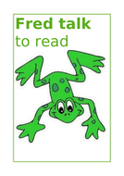
Fred is a Frog we use to help teach oral blending. We also like to use a class puppet called Fred to Fred talk. One of the Physical Development challenges for this week will be making your own Fred puppet. Watch out for Tapestry for this challenge.
Physical Development
Here is a reminder of the topic challenge that I posted on Tapestry last week:
Physical Development Challenge:
Stepping Stones
Last week’s physical development challenge was exploring different ways of travelling by playing a game of ‘cross the river’
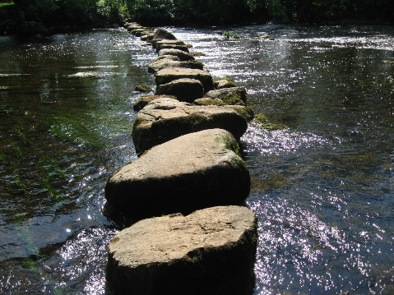
Cross the River Challenge: Set up some stepping stones using cushions, paper or anything you can find to make suitable stepping stones. Experiment with travelling across the stepping stones in different ways without falling and splashing into the river. You could hop, leap, skip, jump or use tiptoes. See if you can count how many jumps/hops/leaps it takes to get across the river.
You could make it trickier by adding stepping stones, or increasing the distance between the stepping stones or even by making the stepping stones smaller to make it more difficult to balance!
This week’s Physical development challenge will be a fine motor focus, by using our fingers to craft and making a sock puppet to use with our Phonics/Literacy challenge.
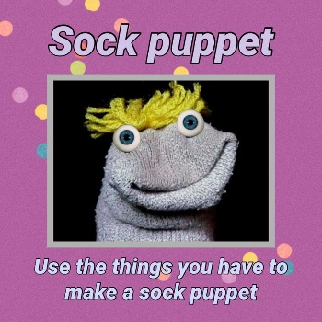

Tapestry learning webs – Prime and Specific areas
Following on from Week 1-7 of the learning webs they have now uploaded week 8. Week 8 focuses on specific areas such as Maths, Reading and Mark Making. One of my favourite activities is the ‘Mark Making’. This demonstrates how mark making can take on lots of different forms. Not just sitting at a table and drawing and writing. Take a look and be sure to have lots of fun mark making!
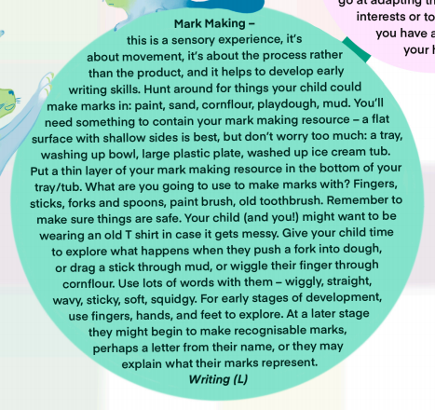

Please get in touch through the email learning@beechwoodprimaryschool.co.uk if you need any support with tapestry or for any other learning related query.

Please look after yourself and keep in touch.

Mrs Isenring

