Nursery Home Learning – Monday 4th May

Topic – Plants and Animals
Here is a reminder of the topic challenge that I posted on Tapestry last week:
Topic Challenge
Last week’s topic challenge was to start to explore growing. I started to do my planting and I looked at different seeds. I also looked after the plants that have already grown in my garden. To explore growing further I looked at and read the story of ‘Jaspers Beanstalk’.
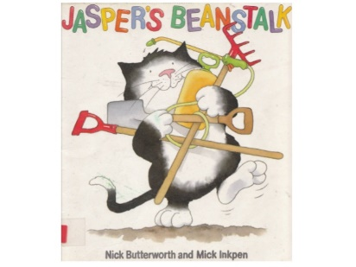
Challenge: To look at your gardens/local area to see what you can find that is growing. Also, if you have the tools and resources to have a go at doing some of your own planting. To explore how you look after plants to make sure they grow.
This week we are going to start looking at vegetables and explore the book ‘Oliver’s Vegetables.’
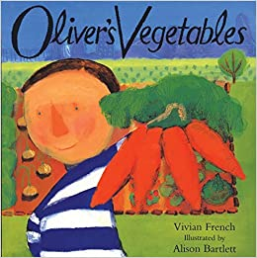
Maths
Please remember to do daily active counting!
Here is the reminder of the Maths challenge that I posted on tapestry:
Maths Challenge:
Lasy week’s maths challenge was all about helping your child develop their subitising skill. Subitising is the skill to be able to recognise numbers of things without counting. Subitising can help children to build images for numbers and help them better understand the 'howmanyness' of a number. It also helps them to see numbers inside a number. For instance, a two and a two makes four. This will help them as they begin to calculate.
The best way to start to develop this skill is a lot of playing with dotted dice.
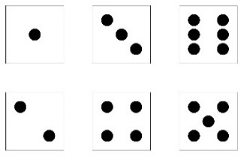
Maths Challenge:
To play a game or make up your own game that encourages play with a dice/spinner. If you don't have a dice, you could make your own out of an old box or use an online dice or a dice app.
As you play with the dice encourage your child to recognise the pattern of dots without counting. Don't worry if you have to count to start with, repetition is the key and with lots of repetition they will start to be able to recognise the amount without counting.
This week we will do some maths work based on the book ‘The Hungry Caterpillar’. Why don’t you watch it here ahead of the maths challenge? https://www.youtube.com/watch?v=75NQK-Sm1YY
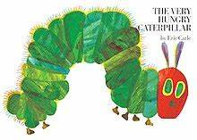
Literacy
Story time – Please set aside some time each day to share a book and sing nursery rhymes together. Don’t worry if you’re reading the same book again or always singing the same rhyme as repetition is key at this age.
Here is a reminder of the Literacy challenge that I posted on Tapestry last week:
Literacy Challenge:
Rhyming Book ‘Oi Dog’ By Kes Gray
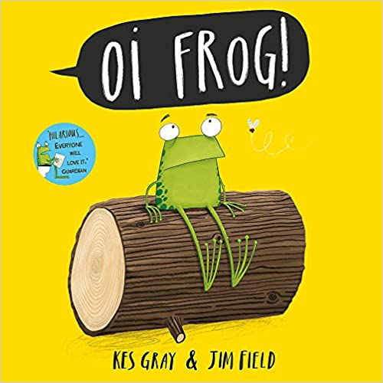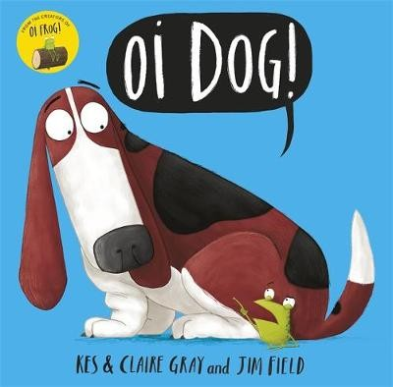
I posted a video of me reading the second rhyming story in the series called ‘Oi Dog’ by Kes Gray.
We continued explored the concept of rhyme.
Challenge: Using four words, three rhyming words and one word that doesn’t can you work with your child to see if they can figure out which is the odd one out?
For example: ‘cat, rat, dog, mat’ or ‘slug, hen, pen, ten’

This week we will be exploring our enjoyment of Reading by making reading dens and exploring our favourite stories and making a comfy and fun place to read.
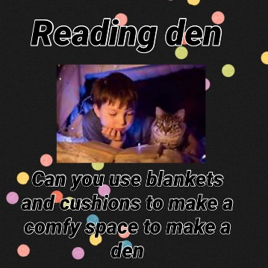
Physical Development
Here is a reminder of the topic challenge that I posted on Tapestry last week:
Physical Development Challenge:
Last week’s physical development challenge was all about fine motor development. You can develop these fine motor skills however you like using a wide range of resources, tools and activities.
I posted a couple of ideas and suggestions to keep those fingers busy.
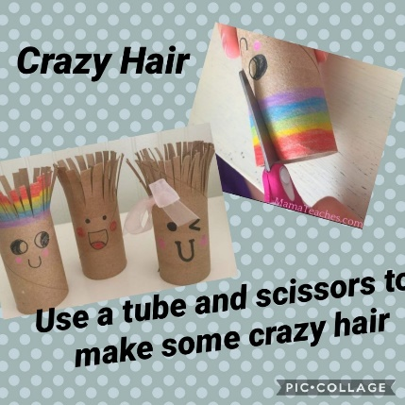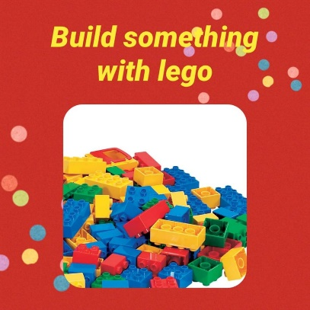
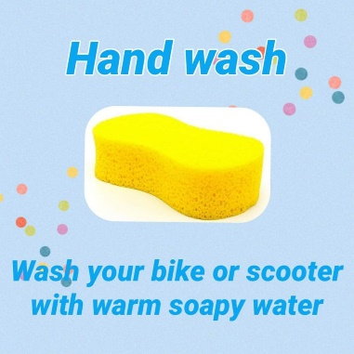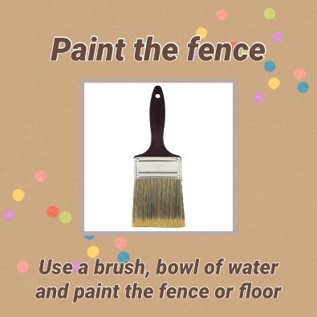

This week we will be exploring different ways of travelling by playing a game of ‘cross the river’ where we have to be careful not to fall and make a big splash.

Tapestry learning webs – Prime and Specific areas
Following on from Week 1-6 of the learning webs they have now uploaded week. Week 7 focuses on prime areas such as communication and language, physical development and personal, social and emotional development. One of my favourite activities is the ‘Making lunch’ and the discussion about why fruit and vegetable are good for us. This will link in very nicely to our topic challenge!

Home learning packs
Some have you have been into school to collect some of the home learning packs. Tapestry is still the main way I will be communicating and setting challenges but the home learning packs are there just to support alongside and really help those that are not using Tapestry.

Please get in touch through the email learning@beechwoodprimaryschool.co.uk if you need any support with tapestry or for any other learning related query.

Please look after yourself and keep in touch.

Mrs Isenring

