Nursery Newsletter – Monday 27th April

Topic – Plants and Animals
Here is a reminder of the topic challenge that I posted on Tapestry last week:
Topic Challenge
It would be wonderful if you could talk to your child about all the things they already know about plants. Do they know how to successfully plant some seeds? have they planted anything before? what do seeds need in order to grow? Do you see any plants when you go on your daily walk or in your garden? Can they name any of the plants they can see? Can you see a Beech tree?
Watch this little clip and look at this website to help get the discussion started https://youtu.be/fwCe3zzNzL8 https://www.bbc.co.uk/cbeebies/grownups/how-does-your-garden-grow?collection=national-gardening-week
Can you draw a picture of something you have seen or make a plant collage?
This week I am going to start my planting at home and I am going to plant some seeds. It would be great if you could do some planting at home.
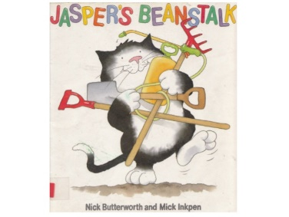
I am also going to be looking at a book called ‘Jaspers Beanstalk’ by Nick Butterworth. Watch out for Tapestry as I will post a video of me reading the story.
Maths
Please remember to do daily active counting! Jumping, clapping, using silly voices. Counting to 10 and then 20 forwards and backwards.
Here is the reminder of the Maths challenge that I posted on tapestry:
Maths Challenge:
I posted three videos of me doing lots of counting.
Counting objects that can’t be moved: In the 1st video I did lots of counting with things that can’t be moved and I used the book 10 black dots to demonstrate how we have to count these arrangements of objects number to each object.
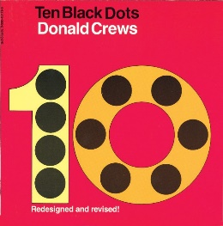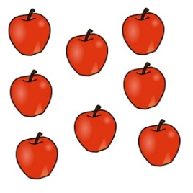
Counting objects that can’t be seen: In the 2nd video I did some counting of claps, trying really hard to count inside our heads. Have a go at doing 5 claps and see if your child is able to accurately count them. Try with a range of numbers.
Counting objects that can be moved: In the 3rd video I showed that if an object can be moved, how we can arrange objects in a line to make counting easier. I talked about starting at the beginning and slowly counting each item.
Have fun doing lots of counting in a range of different ways.
Next week we will continue to look at counting arrangements but we will look at the skill of subitising. This is where children don’t have to rely on counting but recognise what the number is just by looking, such as the dots on a dice.
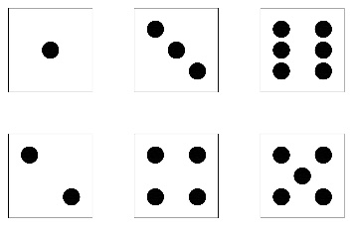

Literacy
Story time – Please set aside some time each day to share a book and sing nursery rhymes together. Don’t worry if you’re reading the same book again or always singing the same rhyme as repetition is key at this age.
Here is a reminder of the Literacy challenge that I posted on Tapestry last week:
Literacy Challenge:
Rhyming Book ‘Oi Frog’ By Kes Gray
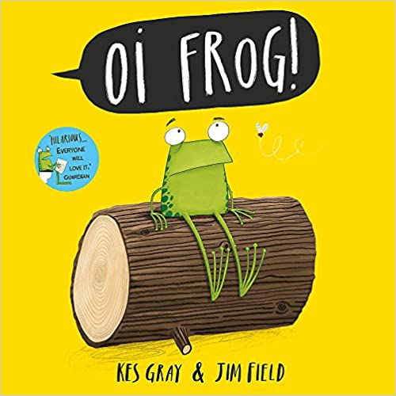
I posted a video of me reading a rhyming story called Oi Frog by Kes Gray.
We explored the concept of rhyme. A rhyming word is a word that has the same end sound. Such as log, hog, fog, dog, frog. They all have the og sound at the end and this is called a rhyming string.
Hearing rhymes and making a rhyming string is a crucial skill we develop in nursery. As it means we are tuning into the sounds and words that we hear.
Challenge: Can you make a rhyming string for at, so hat, bat.... can you think of any more rhyming words?
What about og, or en? It doesn't matter if they are made up silly words as the crucial thing here is hearing the rhyme.
Next week we will continue with the focus of rhyme and I will read the next silly rhyming story in the series ‘oi dog’ by Kes Gray. Remember to post any videos or lists of rhyming words that you have been able to come up with your child.
Physical Development
Here is a reminder of the topic challenge that I posted on Tapestry last week:
Physical Development Challenge:

Put on some of your favourite music and have lots of fun dancing around to it. Try and move in different ways and get your body moving.
Why don’t you use a piece of ribbon or a scarf like we do in nursery to move around while you dance to the music. Use your 'crocodile fingers' (two fingers and thumb) to grip the material. See if you can throw it up and release it in the air and then catch it.
Have fun dancing.
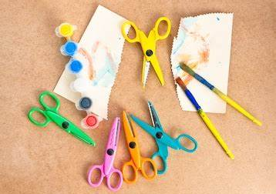
Next week we will be doing a fine motor focus where we have to play and explore using tools such as scissors, paintbrushes, pens, squirter bottles to help strengthen our muscles in our hands.
Tapestry learning webs – Prime and Specific areas
Following on from Week 1-5 of the learning webs they have now uploaded week 6. Week 6 focuses on specific areas such as reading, writing and maths. Remember, these are a great tool and have some great suggestions so please do use them.

Tapestry
Most parents are now accessing Tapestry regularly and this is where home learning activities are being set. Each week there will be 1 maths challenge, 1 literacy challenge, 1 physical development challenge and 1 topic related challenge. The newsletter will also now have a reminder of last week’s challenges in case you are finding it difficult to access tapestry.
Home learning packs
I have also created another home learning pack as I have had some requests for print outs. These will contain the tapestry topic webs and newsletters that have been posted to tapestry/website and some more activity sheets. They will be left in the school office. These will be available to pick up from the 28th April.

Please get in touch through the email learning@beechwoodprimaryschool.co.uk if you need any support with tapestry or for any other learning related query.

Please look after yourself and keep in touch.

Mrs Isenring

