Nursery Home Learning – Monday 20th April
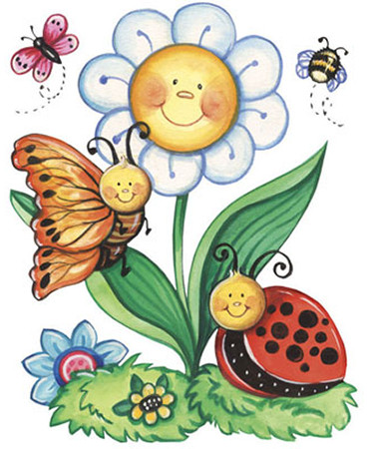
Topic – Plants and Animals
It is officially the start of a new term and the introduction of a new topic. Our new topic is Plants and Animals. We are going to be focusing on planting and growing first and I will be adding regular topic challenges to Tapestry.
If you are able to get hold of any seeds and compost to do some planting at home this would be very useful.
Maths
Please remember to do daily active counting! Jumping, clapping, using silly voices. Counting to 10 and then 20 forwards and backwards.
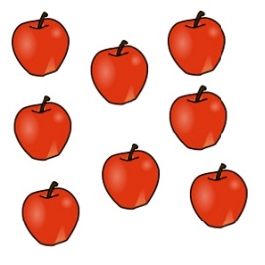
A maths challenge will be added to Tapestry this week with the main focus on counting. We will be looking at and exploring the different ways you can help your child with their counting and different activities you could be doing at home. We will be looking at how children need to tag each object with one number word and we will look at how objects can be arranged to better help counting. We will also explore how children need experience with counting things that can’t be seen, touched or moved such as sounds or pictures on a screen.

Literacy
Story time – Please set aside some time each day to share a book and sing nursery rhymes together. Don’t worry if you’re reading the same book again or always singing the same rhyme as repetition is key at this age.
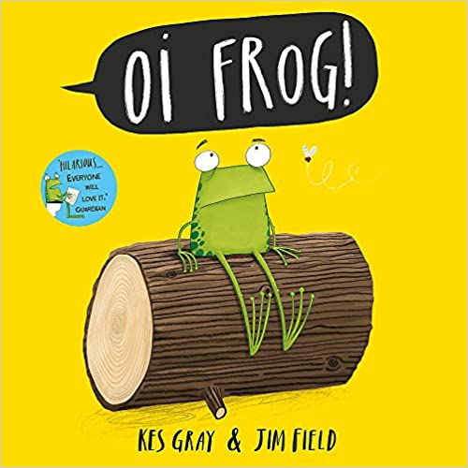
I will be adding a video this week of me reading a rhyming story called ‘Oi Frog’ by Kes Grey through Tapestry. I will also be set a rhyming challenge.

Storytime with Nick – Watch Storytime with Nick; films of well-loved stories read by Nick Cannon, a trained actor, teacher and trainer and a wonderful storyteller. A new story will be added to Ruth Miskins YouTube channel at 2pm on Monday, Wednesday and Friday each week. https://www.youtube.com/channel/UCo7fbLgY2oA_cFCIg9GdxtQ
Ruth Miskin (RML) is the phonics programme that Beechwood School follows.
Physical Development
I will also be posting a physical development challenge this week on Tapestry. Remember to look after both your physical and mental health. They are so important.
Remember to also continue to develop your child’s fine motor control by doing lots of manipulating objects and materials with their fingers. This does not mean doing lots of writing but could mean playing with playdough, making models with Lego, painting the garden with water and paintbrush and cleaning windows. Make it as fun as you can and remember to post how your child is keeping their fingers busy on Tapestry.
Tapestry learning webs – Prime and Specific areas
Following on from Week 1-3 of the learning webs, Tapestry have now uploaded 2 more learning webs. Week 4 – focuses on specific areas such as reading, writing and maths and Week 5 – focuses again on prime areas like in week 2. Remember, these are a great tool and have some great suggestions so please do use them.

Tapestry
Most parents are now accessing Tapestry regularly and it is very important to do so as this is where the home learning activities are being set. Each week there will be 1 maths challenge, 1 literacy challenge, 1 physical development challenge and 1 topic related challenge as this is in line with the group sessions that would have been taking place if we were still in Nursery. If you are having any problems getting onto your Tapestry account, then please email us at learning@beechwoodprimaryschool.co.uk

Please get in touch through the email learning@beechwoodprimaryschool.co.uk if you need any support with tapestry or for any other learning related query.

Please look after yourself and keep in touch.

Mrs Isenring

