Nursery Newsletter – week commencing 30th March
Tapestry Home Learning
Thank you so much for being so active with the tapestry home learning challenges and posting different activities that you are getting up to at home. I loved looking at all the rainbows you sent me. It really made me smile!

There are still a few parents/carers that have not signed up to tapestry. It is crucial that we have this up and running as this is a really good way to keep in touch during this time.
If you have not yet signed up please send an email to learning@beechwoodprimaryschool.co.uk with your child’s name, your full name, email address and relationship to the child.
If you have already given me your email but your account is not yet activated, check your email to see if there is an activation email. It could be that I have added the email incorrectly. If you are having any trouble, please email me with your details so I can get this sorted for you.
Prime Areas
Tapestry have also created a great mind map full of fantastic activities (see below) that you could be getting up to for the three Prime Areas of learning. Remember to share on tapestry any of these activities that you get up to. This document will also be on the website for better viewing.
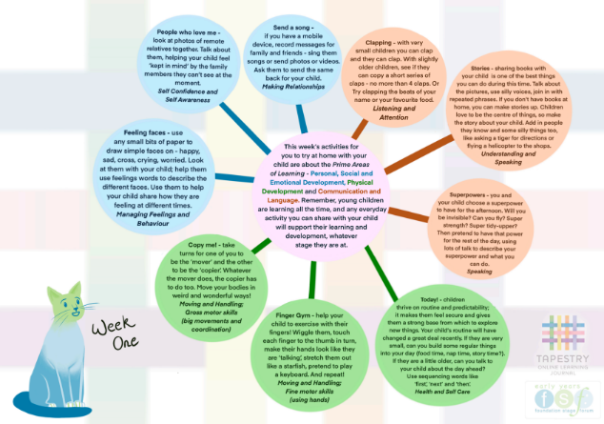
Maths
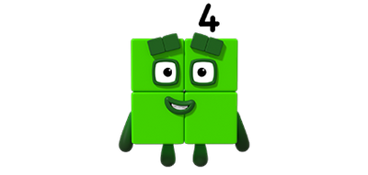
In maths we have done lots of work on the number 1, 2 and 3 using numberblocks. We would have been moving on to look at number 4. If you can please watch the numberblocks episode – Four on IPlayer. It does sometimes come off IPlayer for a time, so if this is not available you can also watch it on youtube.
https://www.bbc.co.uk/iplayer/episode/b08d61cv/numberblocks-series-1-four
https://www.youtube.com/watch?v=cNZl-5A3G5s
Numberblocks is great, it is aimed at introducing children to early number. When we look at a new number we look at lots of different ways of representing it. We can count to 4, we can give a child 4 sweets, we can point to a four pattern on a domino/dice, we can tell a child they are four, we can do 4 claps/stomps/jumps, show 4 fingers and we could cut an apple into 4 pieces. We could also show them how there is 4 legs on a chair/table and we could also look at the numeral 4 and look at how we write it using rhyme ‘down and over, down some more, that’s the way we make a four. We can look at how four is one more than 3 or that on a square there is four sides.
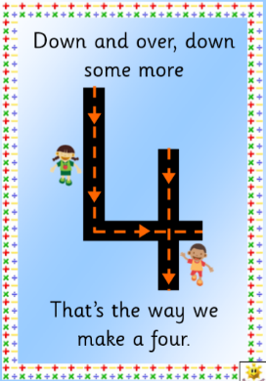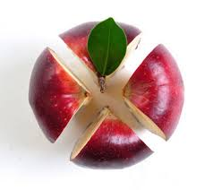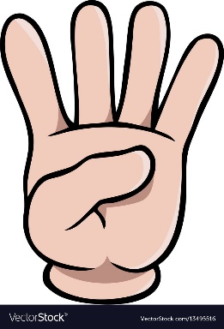
Look at number four with your child and go on a number four hunt around the house. What can you see?
Look out on tapestry for number 4 challenges!

English
Singing
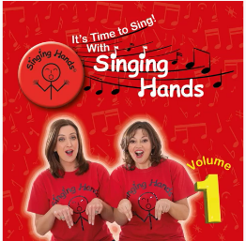
We sing every day in nursery. I use the songs from singing hands. I mainly use ‘It’s Time to Sing Volume 1’ which is available on youtube along with other playlists. https://www.youtube.com/playlist?list=PLjT4XhijakZjU-NjgaHrJGAwzIqYYYbKk
The children especially love these following songs:
- 3 – Hello, How Are You?
- 5 – Wind the Bobbin Up
- 6 – Open, Shut Them
- 7 – Heads, Shoulders, Knees and Toes
- 8 – Incy Wincy Spider
- 9 – If You’re Happy and You Know It
- 10 – I Dig My Garden
- 23 – Mmm Mmm Frog
Enjoy singing and let me know if you find any other great songs.
Reading
Please read and enjoy storybooks every day with your child. These websites have great books to download and listen to:
Audible - Free audio books for all ages- https://stories.audible.com/start-listen
Cbeebies’ Storytime - Storytime is filled with free interactive story books and bedtime stories for young children and is a great way to enjoy reading with your little one. The library is always growing, with amazing stories featuring all the CBeebies’ favourites.
https://www.bbc.co.uk/cbeebies/stories
There is also a Cbeebies Storytime app that can be downloaded and has a library feature where you can download stories for free.
https://www.bbc.co.uk/cbeebies/grownups/cbeebies-storytime-app
Writing and fine Motor
To enable children to have good pen control as they go through school it is crucial that they develop good fine motor skills in their hands. If your child enjoys mark making, then encourage them to hold their pen with crocodile fingers (tripod grip) and explore making lots of pictures and shapes. Talk to your child about what they have drawn. You may also want to practise doing different patterns such as zig zags, waves, circles and lines.
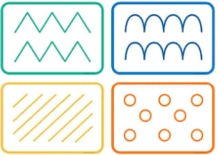
This does not mean that they need to do lots of writing and drawing if they do not normally enjoy doing this type of activity. Some other examples of fine motor may include cutting pieces of paper up, making models with Lego, manipulating playdough, practising using buttons on clothes and pegging up socks onto a line.
Topic - Traditional Tales – The Little Red Hen.
Read the story of the Little Red Hen. (You can find this online.)
Talk about flour and how we make bread. If you have any flour show your child and let them explore this ingredient. Have a look at bread recipes and watch this video https://www.twinkl.co.uk/go/resource/tgv2-t-15-how-to-make-bread-video.

Please look after yourself and keep in touch. I hope to see you all again very soon.
Mrs Isenring

