RECEPTION HOME LEARNING
Week commencing 13th July 2020
SPIRIT ALIVE
Miss Belli’s bubble had an amazing week in school last week celebrating Spirit Alive. We did all sorts of activities related to Australia: we made flags, plasticine Australian animals, boomerangs and even had a barbeque! We have added some photos below!
Thank you for the home learning linked to England/Australia. We have had observations added to Tapestry showing flag making, learning about Big Ben, learning about the Queen and even dressing up as St George! We added lots of activities about both countries in the last work pack.
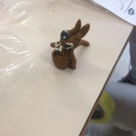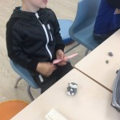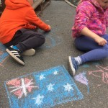
MATHS AND LITERACY
We have prepared a work pack for this week which can be found in the school office.
READING
Please ensure you are reading and listening to stories every day or at least 3 times a week.

TAPESTRY
If you have requested a zip/pdf file this will have been sent now. Year 1 have now decided to use Tapestry so children’s files will roll over into Year 1. We will no longer be able to reply to observations on Tapestry.
It has been wonderful to see some of you in school collecting your reports. We hope you have a wonderful Summer and we can’t wait to give you a wave when you start Year 1.
Keep in touch and stay safe. We miss you all very much.
Mrs Ilsley, Mrs Lyons and Miss Belli

