RECEPTION HOME LEARNING
Week commencing 6th July 2020
SPIRIT ALIVE
Mrs Ilsley’s bubble had an amazing week in school last week celebrating Spirit Alive. We did all sorts of activities related to Australia: we made flags, hats, rain-sticks, boomerangs, fairy bread, Anzac biscuits, koalas, maps and we decorated buns and even had a barbeque! We have added some photos below!
Miss Belli’s bubble will be learning about Australia next week at school.
Thank you for the home learning linked to England/Australia. We have had observations added to Tapestry showing flag making, learning about Big Ben, learning about the Queen and even dressing up as St George! If you learned about England at home last week then learn about Australia this week and vice versa. We added lots of activities about both countries to the last work pack.
Remember that we have three competitions up and running: make a hat to represent your country, draw and colour in your country’s national animal and make and decorate a cake at home. Please send a photo of your cake to learning@beechwoodprimaryschool.co.uk . There are wonderful prizes to be won!
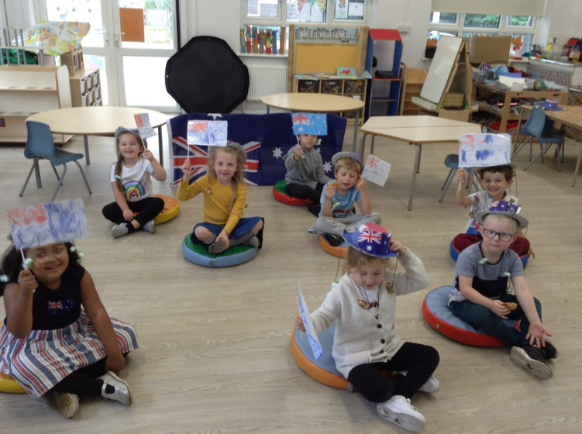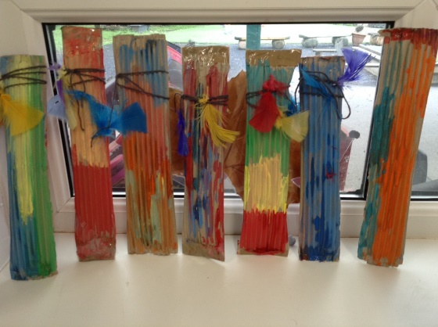
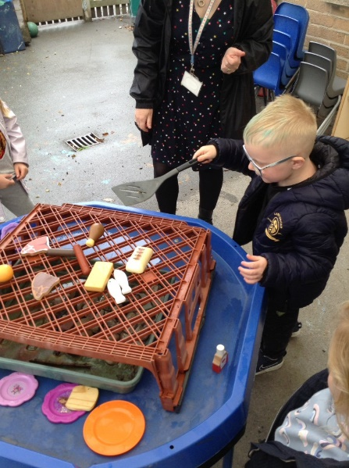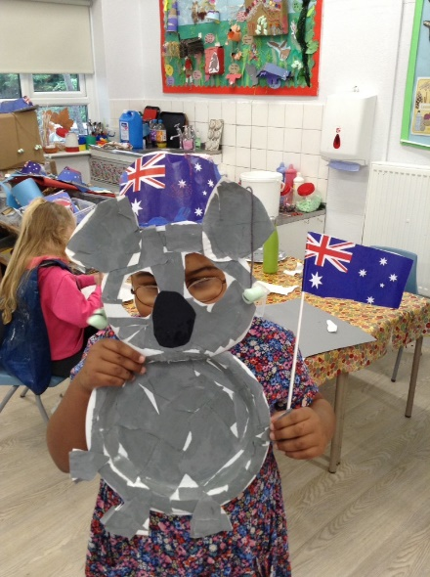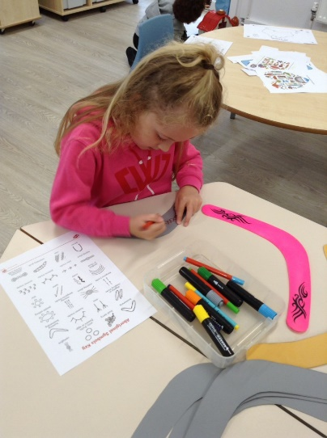

MATHS AND LITERACY
If you require extra maths and literacy activities for this week to do alongside your Spirit Alive activities, you can collect extra work from school during the week. The maths focus this week is part part whole.
READING
Please ensure you are reading and listening to stories every day or at least 3 times a week.

TAPESTRY
As we are nearing the end of the school year we are winding down the Reception accounts for Tapestry. We will continue adding and accepting observations over the coming week but then the accounts will be closed. If you would like a zip file of your child’s learning to be emailed to you please contact us via Tapestry and request this with your current email address as we will be sending these out during the last week of term.
Keep in touch and stay safe. We miss you all very much.
Mrs Ilsley, Mrs Lyons and Miss Belli

