YEAR 1 HOME LEARNING
Week commencing 6thJuly
SPIRIT ALIVE
We hope you have all been enjoying taking part in the Spirit Alive activities for Greece in your home learning packs and on our class pages. Don’t forget to enter these competitions:
- Make a hat to represent your country
- Draw and colour the national animal of your country
- Decorate a cake to show something about your country

You can send your entries to learning@beechwoodprimaryschool.co.uk. The winners will all receive prizes!

KEY WEBSITES
https://www.storynory.com/
Story Noryis a website that allows children to listen to different audiobooks read to them by the author. It also allows you to download the stories to keep for another time. These stories are suitable for children of all ages.

https://www.bbc.co.uk/bitesize/levels/z3g4d2p
BBC Bitesize - excellent range of daily lessons on lots of different subjects for your child to enjoy. New lessons are uploaded every day and include videos, practice activities, games and quizzes to help your child learn. You can watch programmes daily on BBC iPlayer (Bitesize Content)

MATHS
Please click on the link below and follow these lessons for week 11. There is one for each day with a video explaining the mathematical concept. Please complete the activities on a piece of paper or print off the sheet.If possible, send a photo of your home learning via the learning email. We would love to see all the hard work you are doing.
https://whiterosemaths.com/homelearning/year-1/
and
https://whiterosemaths.com/resources/primary-resources/parent-workbooks/

Please use the ‘Summer Term – Week 11’ set of lessons. The sheets to go with each lesson are under Parents ›› Home Learning Support ›› Mathematics ›› and ›› White Rose Maths Sheets on the school website.
ARITHMETIC
Don’t forget to keep practising counting in 2s, 5s and 10s. If you can do that move onto 3s and 4s.

SPELLINGS
The spellings to learn for this week are:
of* said* was* has* come* one* once* ask* your* is*
Please get someone to test you at the end of the week. Keep a record of your scores!

READING
Please keep reading at home! It is very important that you try and read at least 3 x per week. We’d love you to send us a photo of you reading if you haven’t already or a book review (template can be download from the parents, home learning support, reading tab of the school website). You can send them to the email: learning@beechwoodprimaryschool.co.uk .

PSHE


This week we would like you to write about your time in Year 1 and how you feel about going into Year 2. What were your favourite parts about being in Year 1? What did you enjoy doing? Which trips and activities did you like the most?

How do you feel about going into Year 2? What do you think will be different as you move into the next year group? What are you looking forward to? Is there anything you have any worries about that you would like to ask us about?

Please send your work to the learning email: learning@beechwoodprimaryschool.co.uk

PE
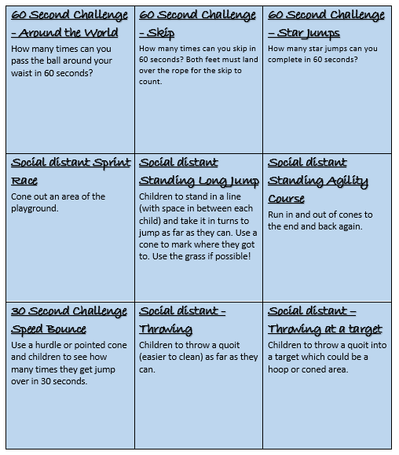
Have a look on the next page for some fun PE ideas to get you moving!

Please look after yourselves and your family and we hope to see you all again very soon.

Mrs Keirl and Miss Karagic

