YEAR 1 HOME LEARNING
Week commencing 27th April
Thank you to everyone who has already written letters back to us. We have really enjoyed reading them. We are very impressed with all the work you are doing at home.
We would love to see any work you have completed. Please send any photos and messages to the following email address- learning@beechwoodprimaryschool.co.uk

WEBSITES – to look at if you haven’t already found them:
www.bbc.co.uk/bitesize/tags/zmyxxyc/year-3-lessons
BBC Bitesize have an excellent range of daily lessons on lots of different subjects for your child to enjoy. New lessons are uploaded every day and include videos, practice activities, games and quizzes to help your child learn.
www.leedsforlearning.co.uk/Page/17071
Leeds for Learning have an excellent range of resources to help support home learning.

MATHS
Please continue to use the following website.
https://whiterosemaths.com/homelearning/year-1/
Please watch the teaching videos and complete the lessons for ‘Summer Term – Week 2’.
For additional arithmetic and times tables practise please use these websites:
Maths Factor – All ages - https://www.themathsfactor.com/
Topmarks - https://www.topmarks.co.uk/maths-games/5-7-years/counting
Remember in Year 1 we need to learn how to count forwards and back from any number in 1s to 100, counts in multiples of 2s, 5s and 10s.
Jack Hartmann Counting in 2s, 5s and 10s - https://www.youtube.com/watch?v=q_yUC1NCFkE
Super movers counting - https://www.bbc.co.uk/teach/supermovers/ks1-maths-counting-with-john-farnworth/zbct8xs

SPELLINGS
The spellings to learn for this week are to spell words with the phoneme ee spelt with ‘y’.

Spellings for Mrs Shaws’s phonics group:

green
seen
knee
tree
sheep
greed
freeze

very
happy
funny
party
family
dizzy
smelly
silly
jolly
funny

Please get someone to test you at the end of the week. Keep a record of your scores!
READING
We now have a mini school library outside the office so you and your child can come and borrow reading books and books to share. Please pop in.
Please ensure you are reading everyday or at least 3 times a week. You can read and/or someone can read to you and ask you questions to check your understanding.
Oxford Reading Owls – A great range of e-books you can read for free that you can choose by age. They also have reading activities to complete after each book - https://www.oxfordowl.co.uk/for-home/find-a-book/library-page/
These websites also have books to download / listen to.
Audible Books – Free audio books for all ages - https://stories.audible.com/start-listen
World Book – Free eBooks and audio books for all ages - https://worldbook.kitaboo.com/reader/worldbook/
Parents have mentioned that they would like more phonics work. We have some worksheets available and please use the link below as it relates directly to the scheme we use and has some videos which you will find really useful…
https://www.youtube.com/channel/UCo7fbLgY2oA_cFCIg9GdxtQ/videos
We are making a phonic pack which will be available for you to collect soon. We will let you know when it is available.

ENGLISH
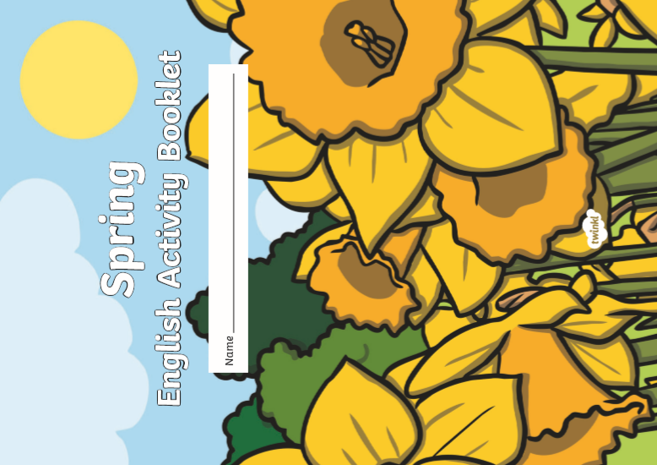
There is a Spring English activity book in the pack we produced last week.
This can be collected from school.
.

TOPIC – Houses and Homes around the World
The next topic we are focusing on is houses and homes around the world. We learn about the different types of houses you can find in the UK. For example- detached homes, semi-detached, bungalows, houseboats, cottages, flats and caravans. Can you draw the different types of houses and write a sentence about each one. We would love to see what you do.
We’ve not seen any homes yet so don’t forget to email them in to
learning@beechwoodprimaryschool.co.uk

PHYSICAL ACTIVITIES
Remember to look after both your physical and mental health. They are so important. These websites will help you keep active.
- Body Coach – Jo Wick live P.E. lesson at 9 am every day – (All ages) https://www.youtube.com/watch?v=K6r99N3kXME
- Cosmic Yoga – https://www.youtube.com/user/CosmicKidsYoga
- Stay Active – Premier Education Free activities to stay active at home https://www.premier-education.com/stay-active/
- Imoves - https://imoves.com/imovement-signup

We hope you can complete as many of these activities throughout the week and really look forward to seeing all your hard work! The Spring activity books will take you longer than a week to complete and you will need some help.
Remember to email anything you do to…
learning@beechwoodprimaryschool.co.uk

Please look after yourselves and your family and we hope to see you all again very soon.

Mrs Keirl and Miss Karagic x

