Year 1 newsletter week commencing 30/3/20
Dear parents/carers,
Here are some more ideas of what you can do with your child at home.
This is a great website for maths, English and the national curriculum.
https://uk.ixl.com

Maths
Continue daily work using the objectives below + we have added some extra ideas.
- Learning to count forwards and backwards in 1s to 100 from different numbers. For example, you say 64,63,62 then they say the next three numbers.
- Counting in 2s (odd and even), 5s and 10s
- Recalling number bonds to 10 off by heart (10+0 = 10, 1 + 9=10, 2+8 =10 etc)
- Count, read and write numbers to 100. Spelling numbers to 20.
- Give one more or one less of a number
- Solve addition and subtraction number problems (e.g. 3 = ? – 4, 14 + ? = 16)

Double numbers to 20 and halves.
Learn this rap…
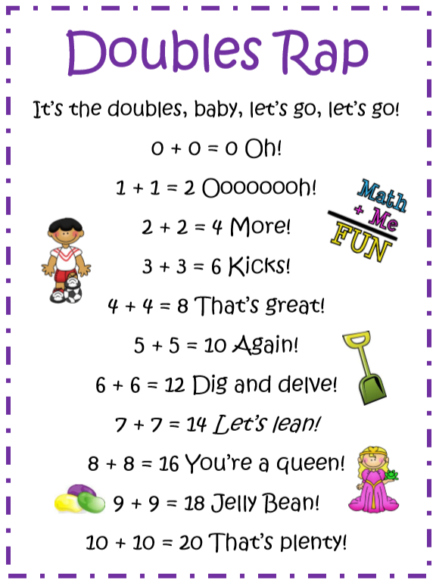
Science Challenge
How many different kinds of animals can you find in your garden? Please draw and label them.

English/Phonics
Please cut up and use the phonic (sound) cards we have provided. These need to be done every day.
Phonics Play - https://www.phonicsplay.co.uk/freeIndex.htm
Ask your child to write a story about a child finding a dragon’s egg. Help them as they must write in sentences using capital letters and full stops. Then they can draw an amazing picture or pictures illustrating their story.
We are really looking forward to reading them.
Continue to practise the national word list for Year 1 spellings with your child.

Reading
Read a book at least three times a week. You can find books online to read or use ones you have at home. Your parents can also read to you. Ask your child what might happen in the book by just looking at the front cover. Then ask questions throughout the book to see if they understand the story.

Topic Work
As you know we have been learning about food around the world. As part of this topic the children wanted to learn more about sandwiches around the world. Please do some research with your child and find out about sandwiches around the world then either type or write this information down.
Then choose a sandwich and draw a labelled plan of it.

You must say which country it is from and add any additional information.
Then you could make it (with parent/carer supervision) and photograph it. Send the photograph so we can see it, then eat it up!
Please Note - If it is difficult to source the ingredients, then just do the plan as you can always make it at a future date.
We are missing you all and are looking forward to seeing all the work you do.
Take Care
The Year 1 Team

Sliced bread

ham
tomato

lettuce

