YEAR 1 HOME LEARNING
Week commencing 13thJuly
This will be the final newsletter before the summer holidays. Here are some ideas to keep you busy during the summer and help you get ready for starting Year 2. Thank you to everyone who has sent work to the learning email or picked up work packs. There is one more work pack available now if you would like to collect it.
KEY WEBSITES
https://www.storynory.com/
Story Nory is a website that allows children to listen to different audiobooks read to them by the author. It also allows you to download the stories to keep for another time. These stories are suitable for children of all ages.
https://www.bbc.co.uk/bitesize/levels/z3g4d2p
BBC Bitesize are still posting free online lessons for all subjects until 24th July.

MATHS
Please click on the link below and follow these lessons for week 12. There is one for each day with a video explaining the mathematical concept. Please complete the activities on a piece of paper or print off the sheet.If possible, send a photo of your home learning via the learning email. We would love to see all the hard work you are doing.
https://whiterosemaths.com/homelearning/year-1/
and
https://whiterosemaths.com/resources/primary-resources/parent-workbooks/
Please use the ‘Summer Term – Week 12’ set of lessons. The sheets to go with each lesson are under Parents ›› Home Learning Support ›› Mathematics ›› and ›› White Rose Maths Sheets on the school website.
ARITHMETIC
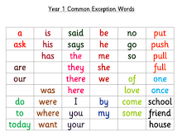
In Year 2, children are expected to know their 2s, 5s and 10 times tables off by heart. It would be great if you could support your child with learning these.
Please also keep supporting your child with doubles and halves to 20 and counting forwards and backwards to 100.
SPELLINGS

Please check your child can spell the words above.

READING
Please keep reading at home! It is very important that you try and read at least 3 x per week. We’d love you to send us a photo of you reading if you haven’t already or a book review (template can be download from the parents, home learning support, reading tab of the school website). You can send them to the email: learning@beechwoodprimaryschool.co.uk .
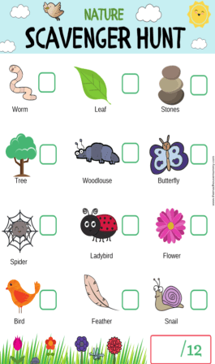

SCIENCE – Nature Scavenger Hunt
Can you get outside and see which things you can find?

Please send your work to the learning email: learning@beechwoodprimaryschool.co.uk

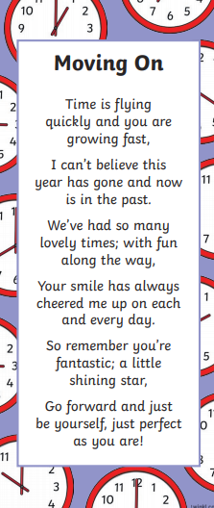
Thank you for all your support and hard work over the past few months. We really appreciate how hard you have worked at home. We hope you all have a fantastic, safe holiday and we look forward to seeing you all in September.
Mrs Keirl and Miss Karagic

