YEAR 1 HOME LEARNING
Week commencing 22nd June
Please keep sending any photos and messages to the following email address- learning@beechwoodprimaryschool.co.uk.We’ve loved seeing how hard you’ve been working at home.
EXCITING NEWS!
Even though we are not all at school, some of Year 6 have been busy thinking about how we can still do Spirit Alive this year. Next week’s work pack will include information about how you can get involved with the fun while you are at home.
WEBSITES https://www.bbc.co.uk/bitesize/tags/zjpqqp3/year-1-and-p2-lessons/1BBC Bitesize have an excellent range of daily lessons on lots of different subjects for your child to enjoy.
MATHS
Please continue to use the following website.
https://whiterosemaths.com/homelearning/year-1/
Please watch the teaching videos and complete the lessons for ‘Summer Term – Week 9, the worksheets will be available on the class pages.
This term we will begin to learn our 2, 10 and 5 times table. Please could you help your child learn the 10x table. This link is to a useful, fun 10x table song!https://www.bbc.co.uk/teach/supermovers/early-ten-times-table/zdphjhv
Read and write numbers from 1 to 20 in numerals and words.
This is an ideal opportunity to teach your child to tell the time. Use a clock or watch with hands and teach them to tell the time to the hour and half past the hour. If they can do this then move onto quarter to and quarter past.
SPELLINGS
To spell compound words.
football
playground
farmyard
bedroom
blackberry
lighthouse
sometimes
bathroom
classroom
teatime
Please get someone to test you at the end of the week. Keep a record of your scores!

READING
Please ensure you are reading everyday or at least 3 times a week. You can read and/or someone can read to you and ask you questions to check your understanding.
Phonics please use the link below as it relates directly to the scheme we use and has some videos which you will find really useful…
https://www.youtube.com/channel/UCo7fbLgY2oA_cFCIg9GdxtQ/videos
https://www.bbc.co.uk/bitesize/subjects/zgkw2hv
WRITING
Can you write a story about some children who find a dragon’s egg.
Where do they find the egg?
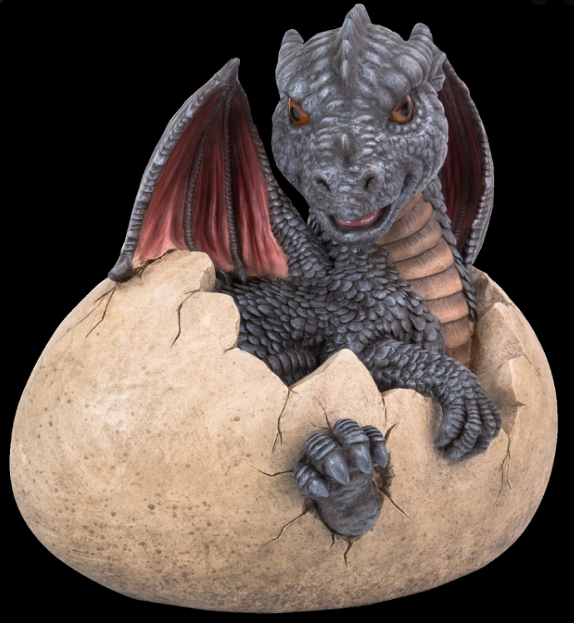
What do they do with the egg?
What happens to the egg?

TOPIC- Houses and Homes (Castles)
Please do some research this week. Find out about castles in the past. Then draw different castles on a timeline and write a sentence about each one.
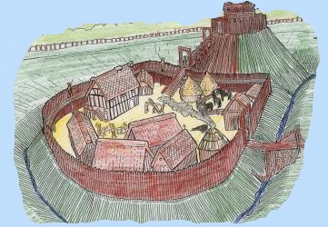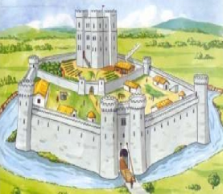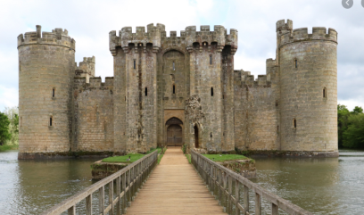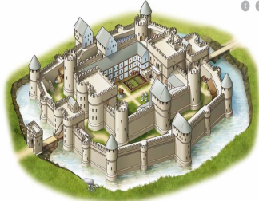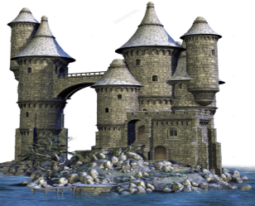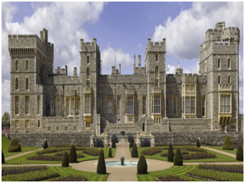
PHYSICAL ACTIVITIES
Can you make up your own dance or copy one online then perform it as a family!
We would love to see what you do… learning@beechwoodprimaryschool.co.uk
We have kept some of the work the same as we haven’t seen many pieces of work so we thought we’d give you a little more time. If you are having difficulty emailing us, then please drop the work off at the office as we would love to see it. Mrs Keirl and Miss Karagic

