YEAR 1 HOME LEARNING
Week commencing 15th June
Please keep sending any photos and messages to the following email address- learning@beechwoodprimaryschool.co.uk.We’ve loved seeing how hard you’ve been working at home.
WEBSITES https://www.bbc.co.uk/bitesize/tags/zjpqqp3/year-1-and-p2-lessons/1BBC Bitesize have an excellent range of daily lessons on lots of different subjects for your child to enjoy.
MATHS
Please continue to use the following website.
https://whiterosemaths.com/homelearning/year-1/
Please watch the teaching videos and complete the lessons for ‘Summer Term – Week 8’, the worksheets will be available on the class pages.
This term we will begin to learn our 2, 10 and 5 times table. Please could you help your child learn the 10x table. This link is to a useful, fun 10x table song!https://www.bbc.co.uk/teach/supermovers/early-ten-times-table/zdphjhv
Read and write numbers from 1 to 20 in numerals and words.
This is an ideal opportunity to teach your child to tell the time. Use a clock or watch with hands and teach them to tell the time to the hour and half past the hour. If they can do this then move onto quarter to and quarter past.
SPELLINGS
To spell numbers to 20
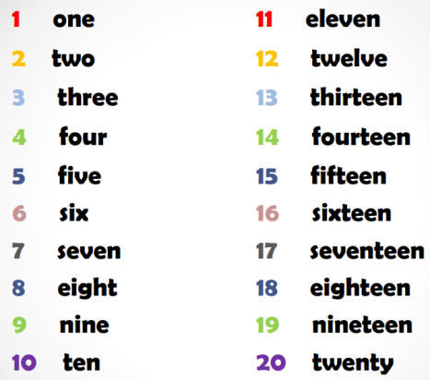
Please get someone to test you at the end of the week. Keep a record of your scores!

READING
Please ensure you are reading everyday or at least 3 times a week. You can read and/or someone can read to you and ask you questions to check your understanding.
Phonics please use the link below as it relates directly to the scheme we use and has some videos which you will find really useful…
https://www.youtube.com/channel/UCo7fbLgY2oA_cFCIg9GdxtQ/videos
https://www.bbc.co.uk/bitesize/subjects/zgkw2hv
WRITING
Can you write a story about some children who find a dragons egg.
Where do they find the egg?
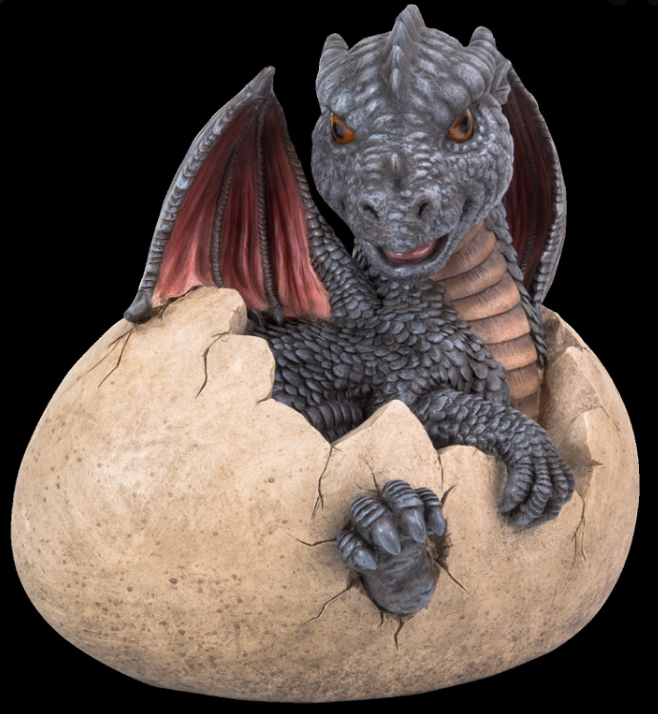
What do they do with the egg?
What happens to the egg?

TOPIC- Houses and Homes (Castles)
Please do some research this week. Find out about castles in the past. Then draw different castles on a timeline and write a sentence about each one.
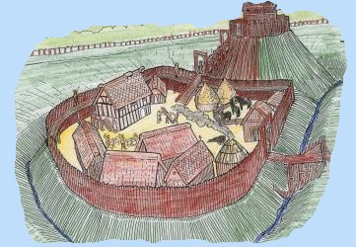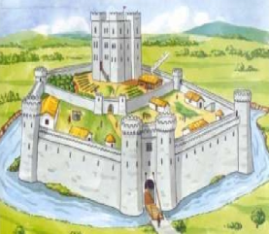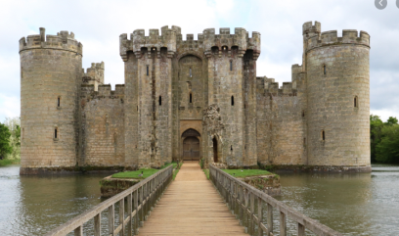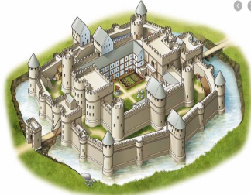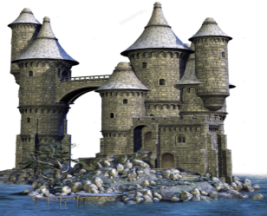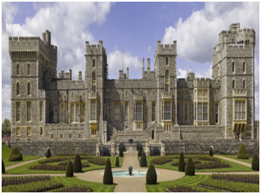
PHYSICAL ACTIVITIES
Can you make up your own dance or copy one online then perform it as a family!
We would love to see what you do… learning@beechwoodprimaryschool.co.uk

Mrs Keirl and Miss Karagic

