YEAR 1 HOME LEARNING
Week commencing ^{8th} June
Please keep sending any photos and messages to the following email address- learning@beechwoodprimaryschool.co.uk.We’ve loved seeing how hard you’ve been working at home.
WEBSITES https://www.bbc.co.uk/bitesize/tags/zjpqqp3/year-1-and-p2-lessons/1 BBC Bitesize have an excellent range of daily lessons on lots of different subjects for your child to enjoy.
MATHS
Please continue to use the following website.
https://whiterosemaths.com/homelearning/year-1/
Please watch the teaching videos and use the ‘Summer Term – Week 7’ set of lessons. The sheets to go with each lesson are under Parents ›› Home Learning Support ›› Mathematics ›› and ›› White Rose Maths Sheets on the school website.
This term we will begin to learn our 2, 10 and 5 times table. Please could you help your child learn the 10x table. This link is to a useful, fun 10x table song! https://www.bbc.co.uk/teach/supermovers/early-ten-times-table/zdphjhv
1 more 1 less – Please work with your child to recognise 1 more and 1 less of any given number to 100.
SPELLINGS
This week’s spellings are compound words. Please teach your child that a compound word is when two words join together to make a new word.
Spellings for Mrs Shaws’s phonics group:
saw
draw
yawn
crawl
straw
blackberry
football
playground
farmyard
bedroom
butterfly
popcorn
Please get someone to test you at the end of the week. Keep a record of your scores!
READING
Please ensure you are reading every day or at least 3 times a week. You can read and/or someone can read to you and ask you questions to check your understanding.
Phonics please use the link below as it relates directly to the scheme we use and has some videos which you will find really useful…
https://www.youtube.com/channel/UCo7fbLgY2oA_cFCIg9GdxtQ/videos
https://www.bbc.co.uk/bitesize/subjects/zgkw2hv
WRITING
Please can you write 3 sentences about what you have enjoyed doing at home. Make sure you start a sentence with a capital letter and finish it with a full stop. Make sure your handwriting is neat and you form your letters correctly.
TOPIC- Houses and Homes (Castles).
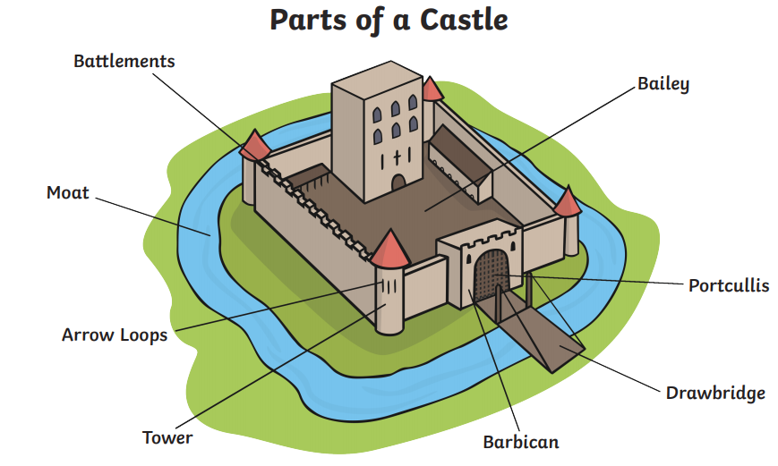
Can you research castles and create your own castles picture? Can you label your picture?
learning@beechwoodprimaryschool.co.uk

PHYSICAL ACTIVITIES
Could you play follow the leader with your family?
The leader could do different physical activities like:
-Star jumps - Skipping - Jumping
- Jogging on the spot - Side steps - Dancing

Mrs Keirl and Miss Karagic x

