YEAR 1 HOME LEARNING
Week commencing 1st June
Please keep sending any photos and messages to the following email address- learning@beechwoodprimaryschool.co.uk.We’ve loved seeing how hard you’ve been working at home.
WEBSITES https://www.bbc.co.uk/bitesize/tags/zjpqqp3/year-1-and-p2-lessons/1 BBC Bitesize have an excellent range of daily lessons on lots of different subjects for your child to enjoy. New lessons are uploaded every day and include videos, practice activities, games and quizzes to help your child learn. You can watch programmes daily on BBC iPlayer.
MATHS
Please continue to use the following website.
https://whiterosemaths.com/homelearning/year-1/
Please watch the teaching videos and complete the lessons for ‘Summer Term – Week 6’, the worksheets will be available in the new learning packs.
This term we will begin to learn our 2, 10 and 5 times table. Please could you help your child learn the 2x table. This link is to a useful, fun 2x table song! https://www.bbc.co.uk/teach/supermovers/ks1-maths-the-2-times-table-with-bridget-the-lioness/zrrx92p
Please keep helping your child count forwards and backwards to 100 in 1s!
SPELLINGS
Spellings for Mrs Shaws’s phonics group:
girl
bird
first
shirt
third
twirl
dolphin
alphabet
phonics
elephant
phone
sphere
Please get someone to test you at the end of the week. Keep a record of your scores!

READING
Please ensure you are reading everyday or at least 3 times a week. You can read and/or someone can read to you and ask you questions to check your understanding.
Phonics please use the link below as it relates directly to the scheme we use and has some videos which you will find really useful…
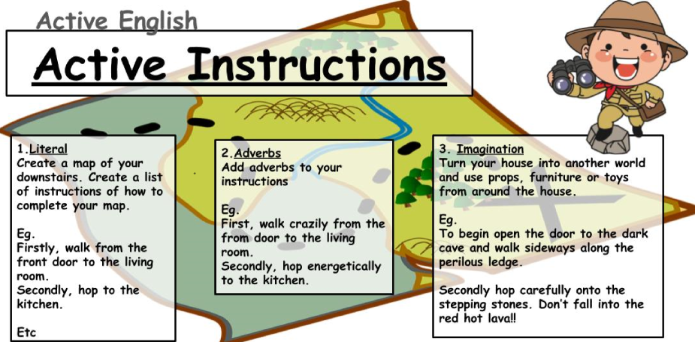
https://www.youtube.com/channel/UCo7fbLgY2oA_cFCIg9GdxtQ/videos
Science – Everyday Materials
BBC Bitesize have some useful videos to help learning https://www.bbc.co.uk/bitesize/topics/zrssgk7
You could explore what happens when you take ice out of the freezer – what is ice? What happens when it is in your hand? What does it turn into?
You could investigate different materials that you have at home – can you find anything that is made from wood, plastic, metal or glass?
Then you could explore the different materials and what they feel like – are they smooth? Are they rough? Are they hard or soft?
learning@beechwoodprimaryschool.co.uk

PHYSICAL ACTIVITIES
Can you try this challenge?
https://primarypeplanning.com/home-pe-ks1-challenge-activities/

Mrs Keirl and Miss Karagic x

