YEAR 1 HOME LEARNING
Week commencing 20th April
MATHS
Please click on the link below and follow these lessons. There is one for each day with a video explaining the mathematical concept. Please complete the activities on a piece of paper or print off the sheet. If possible, send a photo of your home learning via the learning email. We would love to see all the hard work you are doing.
https://whiterosemaths.com/homelearning/year-1/
Please watch the teaching videos and complete the lessons for ‘Summer Term – Week 1’.
For additional arithmetic and times tables practise please use these websites:
Maths Factor – All ages - https://www.themathsfactor.com/
Topmarks - https://www.topmarks.co.uk/maths-games/5-7-years/counting
Remember in Year 1 we need to learn how to count forwards and back from any number in 1s to 100, counts in multiples of 2s, 5s and 10s.
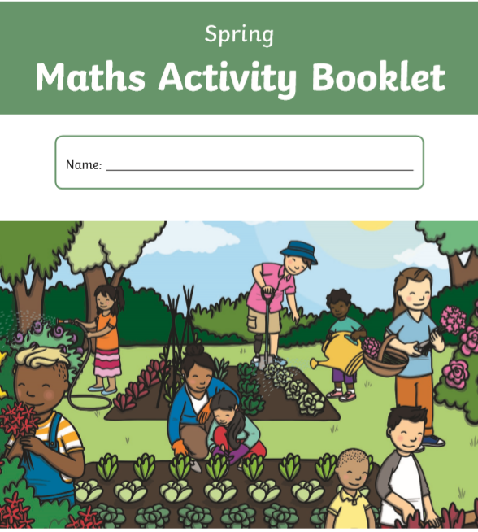
There is a Spring Maths activity book in the pack.
SPELLINGS
The spellings to learn for this week
are to use the vowel digraphs ‘ow’ and ‘ou’.
Spellings for Mrs Shaws’s phonics group:

crab
crop
trap
trip
prim
prep
brat
brick

now
how
brown
down
town
out
about
mouth
sound
you

Please get someone to test you at the end of the week. Keep a record of your scores!
READING
Please ensure you are reading everyday or at least 3 times a week. You can read and/or someone can read to you and ask you questions to check your understanding.
Oxford Reading Owls – A great range of e-books you can read for free that you can choose by age. They also have reading activities to complete after each book - https://www.oxfordowl.co.uk/for-home/find-a-book/library-page/
These websites also have books to download / listen to.
Audible Books – Free audio books for all ages - https://stories.audible.com/start-listen
World Book – Free eBooks and audio books for all ages - https://worldbook.kitaboo.com/reader/worldbook/
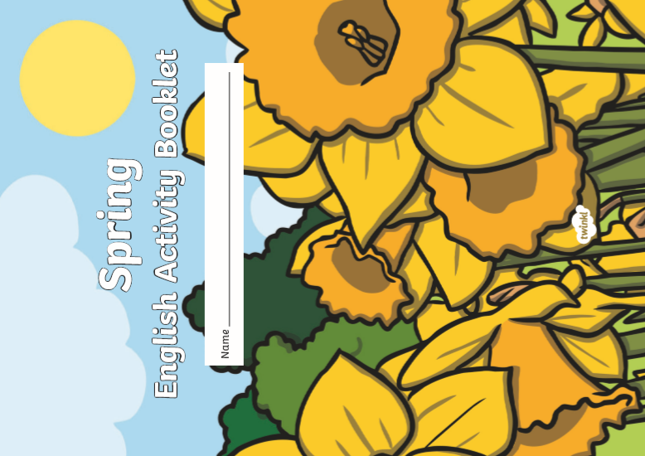

ENGLISH
There is a Spring English activity book in the pack.

If you would like to borrow some books from the school library, please email us: learning@beechwoodprimaryschool.co.uk
A new story will be added to Ruth Miskins YouTube channel at 2pm on Monday, Wednesday and Friday each week. https://www.youtube.com/channel/UCo7fbLgY2oA_cFCIg9GdxtQ
Ruth Miskin (RML) is the phonics programme that Beechwood School follows.

TOPIC – Houses and Homes around the World
The next topic we are focusing on is houses and homes around the world. We learn about the different types of houses you can find in the UK. For example- detached homes, semi-detached, bungalows, houseboats, cottages, flats and caravans. Can you draw the different types of houses and write a sentence about each one? We would love to see what you do. You could send us a photo to: learning@beechwoodprimaryschool.co.uk
PHYSICAL ACTIVITIES
Remember to look after both your physical and mental health. They are so important. These websites will help you keep active.
- Body Coach – Jo Wick live P.E. lesson at 9 am every day – (All ages) https://www.youtube.com/watch?v=K6r99N3kXME
- Cosmic Yoga – https://www.youtube.com/user/CosmicKidsYoga
- Stay Active – Premier Education Free activities to stay active at home - https://www.premier-education.com/stay-active/

We hope you can complete many of these activities throughout the week and we really look forward to seeing all your hard work. The Spring activity books that you can collect from school will take you longer than a week to complete and you will need some help.
Please look after yourselves and your family and we hope to see you all again very soon.
Mrs Keirl and Miss Karagic

