YEAR 2 HOME LEARNING
Week commencing 13th July
This will be the final newsletter before the summer holidays. Here are some ideas to keep you busy during the summer and help you get ready for starting Year 3. Thank you to everyone who has sent work to the learning email or picked up work packs. We are really impressed with how hard you have worked over the last few months. There is one more work pack available now if you would like to collect it.

KEY WEBSITES
https://www.bbc.co.uk/bitesize/levels/z3g4d2p
BBC Bitesize are still posting free online lessons for all subjects until 24th July.

http://www.leedsforlearning.co.uk/Article/76728
Leeds Library Service are launching an online Summer Reading Challenge. This year's reading challenge from The Reading Agency will celebrate funny books, happiness and laughter. Children taking part in the challenge will join the Silly Squad, an adventurous team of animals who love to have a laugh and get stuck in to all different kinds of funny books!

MATHS
It is really important that you learn and practise these things:
- Quick recall of the 2, 5 and 10 times tables
- Counting forwards and backwards to 100
- Counting on and back in 3s
- Quick mental addition and subtraction of 1 digit numbers
- Number bonds to 10
- Column addition and subtraction of two digit numbers (Please watch Miss Westfield’s videos on the school website to use this method correctly. Go to Children ›› Maths Demonstration Videos ›› Year 2 Methods)

Here are some maths websites that you could use to help you:
https://home.oxfordowl.co.uk/kids-activities/fun-maths-games-and-activities/
https://www.topmarks.co.uk/Search.aspx?Subject=16
https://www.purplemash.com/login/
https://www.ictgames.com/mobilePage/
SPELLINGS
Please make sure you can read and spell all the Year 1 and 2 common exception words. You can use the Spelling Strategies document on our class page for different ideas of how you can practise these.
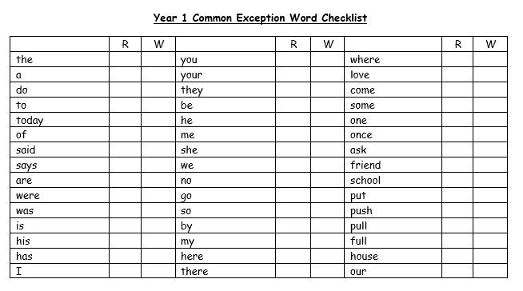
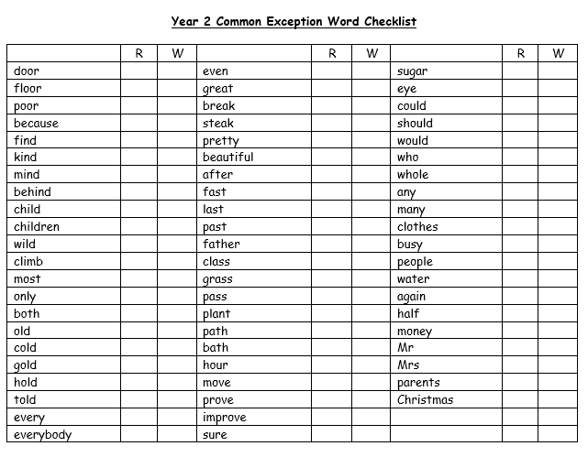
READING
Please keep reading at home! It is very important that you try and read at least 3 x per week.

Remember to look at the Reading’ section under Parents ›› Home Learning Support for links to websites where you can access free e-books, phonics and comprehension activities.

PSHE
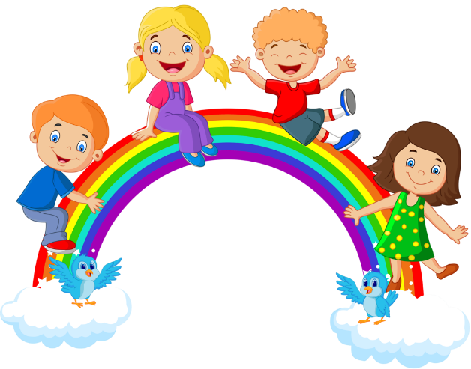

We would like you to write about your time in year 2 and how you feel about going into year 3. What were your favourite parts about being in year 2? What did you enjoy doing? Which trips and activities did you like the most?

How do you feel about going into year 3? What is different about Key Stage 2 compared to Key Stage 1? What are you looking forward to? Is there anything you have any worries about?

You could write this down as a diary entry, make a scrapbook of your favourite memories or just down on paper. Have a go at drawing some pictures to go with your writing! Despite the current situation we have had some wonderful experiences teaching you in year 2 and would love to hear about yours.

Keep safe and enjoy the summer holidays

Miss Westfield and Miss De Biasio

